***FriendofMind*: A Personalized Mental Health Screening and Support Platform**

A Proposal

Presented to the Faculty

of the College of Computer Studies

University of Cebu

Main Campus

In Partial Fulfillment of the Requirement for the Degree

Bachelor of Science in Information Technology

By:  
Cena, Alexes Z.  
Lape, Mark N.  
Muñasque, Stanlee R.  
Nellas, Ivan M.

Mr. Joaquin Patiño  
Adviser

June 2025

# Approval Sheet

# 

# Acknowledgement

We would like to express our sincere gratitude to the **University of Cebu – College of Computer Studies** for providing the opportunity, resources, and academic environment that made this project possible.

Our deepest appreciation goes to our research adviser, **Mr. Joaquin Patiño**, for his invaluable guidance, support, and insightful feedback throughout the course of this study. His patience and encouragement have played a significant role in shaping the development and direction of our research.

We also extend our thanks to the individuals who took part in our surveys and interviews. Their openness in sharing experiences and insights on mental health concerns provided the foundation for understanding the real-world needs that guided the design of *FriendofMind*.

To our instructors and mentors at UC, we are grateful for equipping us with the technical knowledge and critical thinking skills that empowered us to transform ideas into a functional and meaningful platform.

Lastly, we are forever thankful to our families and friends for their unwavering encouragement, emotional support, and belief in our potential. Their presence has been a source of strength throughout this capstone journey. This project would not have been possible without each of you.

# Dedication

This research is wholeheartedly dedicated to all individuals silently battling mental health challenges—especially the youth and young professionals seeking safe, stigma-free support. Your strength and resilience inspire us to create solutions that listen, understand, and guide. *FriendofMind* is built with the hope of being a bridge—one that connects you to early detection, compassionate support, and accessible care.

We also dedicate this work to the students and faculty of the University of Cebu, whose commitment to innovation, research, and social impact continues to motivate us. Your pursuit of knowledge and excellence shaped the foundation of this project and inspired us to build something purposeful.

To our families and loved ones, thank you for your unwavering support, sacrifices, and constant encouragement. Your love has been our strength in moments of doubt and our reason to keep going.

Above all, we dedicate this work to God, whose grace, guidance, and presence sustained us throughout this journey. Every step we took, every challenge we overcame, and every success we achieved is a testament to His faithfulness.

# 

# 

# 

# 

# 

# 

# 

# Table of Content

# 

**Approval Sheet 2**

**Acknowledgement 3**

**Dedication 4**

**Table of Contents 5**

**List of Table 7**

**List of Figures 8**

[**CHAPTER I  
INTRODUCTION 1**](#_heading=h.15h9hkva2ndj)

Rationale of the Study 1

Objectives of the Study 2

Scope and Limitations of the Study 3

Scope of the Study: 3

Limitations of the Study: 4

Significance of the Study 4

Definition of Terms 4

[**CHAPTER II  
REVIEW OF RELATED LITERATURE AND STUDIES 6**](#_heading=h.nl8tjh73nu8d)

Related Literature 6

Related Studies 7

Comparative Analysis 11

[**CHAPTER III   
DESIGN AND METHODOLOGY 14**](#_heading=h.bn9wdys2v55z)

**Research Design 14**

Methodology 14

Flow of the Study 15

Research Environment 16

Respondents 17

Research Instrument 17

Research Procedure 17

Data Gathering 18

Treatment of Data 18

Ethical Considerations 19

Software Engineering Methodology 20

Planning/Conception-Initiation Phase 21

Business Model Canva 21

Program Workflow 22

Validation Board 24  
[Business Road Map 25](https://docs.google.com/document/d/1uZFIhDji_CZbsCZZ9k_ZRrE0YOc7yleR_puODLniyH0/edit?fbclid=IwY2xjawLG9kxleHRuA2FlbQIxMABicmlkETEyVk1ndUR4ZDVrM21PcW9BAR5RzGF-_iltmjCEyE2LfOvzVLkUAZOSwyCqZGf8V8GZtOCue4-bIPx3YCLpsQ_aem_b-im4Cjcy08Xu_r9mqUxCg&tab=t.0#heading=h.uwfpo3xhlrlr)

[Functional Decomposition Diagram 26](https://docs.google.com/document/d/1uZFIhDji_CZbsCZZ9k_ZRrE0YOc7yleR_puODLniyH0/edit?fbclid=IwY2xjawLG9kxleHRuA2FlbQIxMABicmlkETEyVk1ndUR4ZDVrM21PcW9BAR5RzGF-_iltmjCEyE2LfOvzVLkUAZOSwyCqZGf8V8GZtOCue4-bIPx3YCLpsQ_aem_b-im4Cjcy08Xu_r9mqUxCg&tab=t.0#heading=h.mvzkktk2umfs)

[Gantt Chart 27](https://docs.google.com/document/d/1uZFIhDji_CZbsCZZ9k_ZRrE0YOc7yleR_puODLniyH0/edit?fbclid=IwY2xjawLG9kxleHRuA2FlbQIxMABicmlkETEyVk1ndUR4ZDVrM21PcW9BAR5RzGF-_iltmjCEyE2LfOvzVLkUAZOSwyCqZGf8V8GZtOCue4-bIPx3YCLpsQ_aem_b-im4Cjcy08Xu_r9mqUxCg&tab=t.0#heading=h.hy86zp36qpes)

[Analysis-design Phase 29](https://docs.google.com/document/d/1uZFIhDji_CZbsCZZ9k_ZRrE0YOc7yleR_puODLniyH0/edit?fbclid=IwY2xjawLG9kxleHRuA2FlbQIxMABicmlkETEyVk1ndUR4ZDVrM21PcW9BAR5RzGF-_iltmjCEyE2LfOvzVLkUAZOSwyCqZGf8V8GZtOCue4-bIPx3YCLpsQ_aem_b-im4Cjcy08Xu_r9mqUxCg&tab=t.0#heading=h.nmzcyxt41nzg)

[Use Case Diagram 30](https://docs.google.com/document/d/1uZFIhDji_CZbsCZZ9k_ZRrE0YOc7yleR_puODLniyH0/edit?fbclid=IwY2xjawLG9kxleHRuA2FlbQIxMABicmlkETEyVk1ndUR4ZDVrM21PcW9BAR5RzGF-_iltmjCEyE2LfOvzVLkUAZOSwyCqZGf8V8GZtOCue4-bIPx3YCLpsQ_aem_b-im4Cjcy08Xu_r9mqUxCg&tab=t.0#heading=h.xr2im583cbix)

[Storyboard 31](https://docs.google.com/document/d/1uZFIhDji_CZbsCZZ9k_ZRrE0YOc7yleR_puODLniyH0/edit?fbclid=IwY2xjawLG9kxleHRuA2FlbQIxMABicmlkETEyVk1ndUR4ZDVrM21PcW9BAR5RzGF-_iltmjCEyE2LfOvzVLkUAZOSwyCqZGf8V8GZtOCue4-bIPx3YCLpsQ_aem_b-im4Cjcy08Xu_r9mqUxCg&tab=t.0#heading=h.vk8z77s9ouid)

[Database Design 35](https://docs.google.com/document/d/1uZFIhDji_CZbsCZZ9k_ZRrE0YOc7yleR_puODLniyH0/edit?fbclid=IwY2xjawLG9kxleHRuA2FlbQIxMABicmlkETEyVk1ndUR4ZDVrM21PcW9BAR5RzGF-_iltmjCEyE2LfOvzVLkUAZOSwyCqZGf8V8GZtOCue4-bIPx3YCLpsQ_aem_b-im4Cjcy08Xu_r9mqUxCg&tab=t.0#heading=h.lwt3u6ee48bw)

[Entity-Relationship Diagram Relationship Diagram 35](https://docs.google.com/document/d/1uZFIhDji_CZbsCZZ9k_ZRrE0YOc7yleR_puODLniyH0/edit?fbclid=IwY2xjawLG9kxleHRuA2FlbQIxMABicmlkETEyVk1ndUR4ZDVrM21PcW9BAR5RzGF-_iltmjCEyE2LfOvzVLkUAZOSwyCqZGf8V8GZtOCue4-bIPx3YCLpsQ_aem_b-im4Cjcy08Xu_r9mqUxCg&tab=t.0#heading=h.y5526cbyu1r0)

[Data Dictionary 36](https://docs.google.com/document/d/1uZFIhDji_CZbsCZZ9k_ZRrE0YOc7yleR_puODLniyH0/edit?fbclid=IwY2xjawLG9kxleHRuA2FlbQIxMABicmlkETEyVk1ndUR4ZDVrM21PcW9BAR5RzGF-_iltmjCEyE2LfOvzVLkUAZOSwyCqZGf8V8GZtOCue4-bIPx3YCLpsQ_aem_b-im4Cjcy08Xu_r9mqUxCg&tab=t.0#heading=h.nv5q1kiobgjd)

[Network Design 43](https://docs.google.com/document/d/1uZFIhDji_CZbsCZZ9k_ZRrE0YOc7yleR_puODLniyH0/edit?fbclid=IwY2xjawLG9kxleHRuA2FlbQIxMABicmlkETEyVk1ndUR4ZDVrM21PcW9BAR5RzGF-_iltmjCEyE2LfOvzVLkUAZOSwyCqZGf8V8GZtOCue4-bIPx3YCLpsQ_aem_b-im4Cjcy08Xu_r9mqUxCg&tab=t.0#heading=h.il9xn29656lt)

[Network Model 44](https://docs.google.com/document/d/1uZFIhDji_CZbsCZZ9k_ZRrE0YOc7yleR_puODLniyH0/edit?fbclid=IwY2xjawLG9kxleHRuA2FlbQIxMABicmlkETEyVk1ndUR4ZDVrM21PcW9BAR5RzGF-_iltmjCEyE2LfOvzVLkUAZOSwyCqZGf8V8GZtOCue4-bIPx3YCLpsQ_aem_b-im4Cjcy08Xu_r9mqUxCg&tab=t.0#heading=h.snq2dxf2th8z)

[Network Topology 45](https://docs.google.com/document/d/1uZFIhDji_CZbsCZZ9k_ZRrE0YOc7yleR_puODLniyH0/edit?fbclid=IwY2xjawLG9kxleHRuA2FlbQIxMABicmlkETEyVk1ndUR4ZDVrM21PcW9BAR5RzGF-_iltmjCEyE2LfOvzVLkUAZOSwyCqZGf8V8GZtOCue4-bIPx3YCLpsQ_aem_b-im4Cjcy08Xu_r9mqUxCg&tab=t.0#heading=h.nah9z4ohs2z0)

[Development/Construction/Build Phase 46](https://docs.google.com/document/d/1uZFIhDji_CZbsCZZ9k_ZRrE0YOc7yleR_puODLniyH0/edit?fbclid=IwY2xjawLG9kxleHRuA2FlbQIxMABicmlkETEyVk1ndUR4ZDVrM21PcW9BAR5RzGF-_iltmjCEyE2LfOvzVLkUAZOSwyCqZGf8V8GZtOCue4-bIPx3YCLpsQ_aem_b-im4Cjcy08Xu_r9mqUxCg&tab=t.0#heading=h.5j3tsmqcoiq)

[Technology Stack 46](https://docs.google.com/document/d/1uZFIhDji_CZbsCZZ9k_ZRrE0YOc7yleR_puODLniyH0/edit?fbclid=IwY2xjawLG9kxleHRuA2FlbQIxMABicmlkETEyVk1ndUR4ZDVrM21PcW9BAR5RzGF-_iltmjCEyE2LfOvzVLkUAZOSwyCqZGf8V8GZtOCue4-bIPx3YCLpsQ_aem_b-im4Cjcy08Xu_r9mqUxCg&tab=t.0#heading=h.ezz1b6ctgvjx)

[Software Specification 46](https://docs.google.com/document/d/1uZFIhDji_CZbsCZZ9k_ZRrE0YOc7yleR_puODLniyH0/edit?fbclid=IwY2xjawLG9kxleHRuA2FlbQIxMABicmlkETEyVk1ndUR4ZDVrM21PcW9BAR5RzGF-_iltmjCEyE2LfOvzVLkUAZOSwyCqZGf8V8GZtOCue4-bIPx3YCLpsQ_aem_b-im4Cjcy08Xu_r9mqUxCg&tab=t.0#heading=h.i5wkurbdgmaq)

[Hardware Specification 47](https://docs.google.com/document/d/1uZFIhDji_CZbsCZZ9k_ZRrE0YOc7yleR_puODLniyH0/edit?fbclid=IwY2xjawLG9kxleHRuA2FlbQIxMABicmlkETEyVk1ndUR4ZDVrM21PcW9BAR5RzGF-_iltmjCEyE2LfOvzVLkUAZOSwyCqZGf8V8GZtOCue4-bIPx3YCLpsQ_aem_b-im4Cjcy08Xu_r9mqUxCg&tab=t.0#heading=h.vyvvg9wwknhe)

[Program Specification 48](https://docs.google.com/document/d/1uZFIhDji_CZbsCZZ9k_ZRrE0YOc7yleR_puODLniyH0/edit?fbclid=IwY2xjawLG9kxleHRuA2FlbQIxMABicmlkETEyVk1ndUR4ZDVrM21PcW9BAR5RzGF-_iltmjCEyE2LfOvzVLkUAZOSwyCqZGf8V8GZtOCue4-bIPx3YCLpsQ_aem_b-im4Cjcy08Xu_r9mqUxCg&tab=t.0#heading=h.a5mgr5ylw6yi)

[List of Modules 48](https://docs.google.com/document/d/1uZFIhDji_CZbsCZZ9k_ZRrE0YOc7yleR_puODLniyH0/edit?fbclid=IwY2xjawLG9kxleHRuA2FlbQIxMABicmlkETEyVk1ndUR4ZDVrM21PcW9BAR5RzGF-_iltmjCEyE2LfOvzVLkUAZOSwyCqZGf8V8GZtOCue4-bIPx3YCLpsQ_aem_b-im4Cjcy08Xu_r9mqUxCg&tab=t.0#heading=h.rzzd0quan6qi)

[Testing Plan 50](https://docs.google.com/document/d/1uZFIhDji_CZbsCZZ9k_ZRrE0YOc7yleR_puODLniyH0/edit?fbclid=IwY2xjawLG9kxleHRuA2FlbQIxMABicmlkETEyVk1ndUR4ZDVrM21PcW9BAR5RzGF-_iltmjCEyE2LfOvzVLkUAZOSwyCqZGf8V8GZtOCue4-bIPx3YCLpsQ_aem_b-im4Cjcy08Xu_r9mqUxCg&tab=t.0#heading=h.xyrhqgbhzx64)

[Unit Testing 50](https://docs.google.com/document/d/1uZFIhDji_CZbsCZZ9k_ZRrE0YOc7yleR_puODLniyH0/edit?fbclid=IwY2xjawLG9kxleHRuA2FlbQIxMABicmlkETEyVk1ndUR4ZDVrM21PcW9BAR5RzGF-_iltmjCEyE2LfOvzVLkUAZOSwyCqZGf8V8GZtOCue4-bIPx3YCLpsQ_aem_b-im4Cjcy08Xu_r9mqUxCg&tab=t.0#heading=h.xy5kkn5r6fqu)

[Integration Testing 53](https://docs.google.com/document/d/1uZFIhDji_CZbsCZZ9k_ZRrE0YOc7yleR_puODLniyH0/edit?fbclid=IwY2xjawLG9kxleHRuA2FlbQIxMABicmlkETEyVk1ndUR4ZDVrM21PcW9BAR5RzGF-_iltmjCEyE2LfOvzVLkUAZOSwyCqZGf8V8GZtOCue4-bIPx3YCLpsQ_aem_b-im4Cjcy08Xu_r9mqUxCg&tab=t.0#heading=h.9shw961ttvlj)

[Alpha Testing 55](https://docs.google.com/document/d/1uZFIhDji_CZbsCZZ9k_ZRrE0YOc7yleR_puODLniyH0/edit?fbclid=IwY2xjawLG9kxleHRuA2FlbQIxMABicmlkETEyVk1ndUR4ZDVrM21PcW9BAR5RzGF-_iltmjCEyE2LfOvzVLkUAZOSwyCqZGf8V8GZtOCue4-bIPx3YCLpsQ_aem_b-im4Cjcy08Xu_r9mqUxCg&tab=t.0#heading=h.24y92b77y1um)

[References 57](https://docs.google.com/document/d/1uZFIhDji_CZbsCZZ9k_ZRrE0YOc7yleR_puODLniyH0/edit?fbclid=IwY2xjawLG9kxleHRuA2FlbQIxMABicmlkETEyVk1ndUR4ZDVrM21PcW9BAR5RzGF-_iltmjCEyE2LfOvzVLkUAZOSwyCqZGf8V8GZtOCue4-bIPx3YCLpsQ_aem_b-im4Cjcy08Xu_r9mqUxCg&tab=t.0#heading=h.594siksbvhyd)

[CURRICULUM VITAE 60](https://docs.google.com/document/d/1uZFIhDji_CZbsCZZ9k_ZRrE0YOc7yleR_puODLniyH0/edit?fbclid=IwY2xjawLG9kxleHRuA2FlbQIxMABicmlkETEyVk1ndUR4ZDVrM21PcW9BAR5RzGF-_iltmjCEyE2LfOvzVLkUAZOSwyCqZGf8V8GZtOCue4-bIPx3YCLpsQ_aem_b-im4Cjcy08Xu_r9mqUxCg&tab=t.0#heading=h.skyyq2potk6b)

[APPENDICES 64](https://docs.google.com/document/d/1uZFIhDji_CZbsCZZ9k_ZRrE0YOc7yleR_puODLniyH0/edit?fbclid=IwY2xjawLG9kxleHRuA2FlbQIxMABicmlkETEyVk1ndUR4ZDVrM21PcW9BAR5RzGF-_iltmjCEyE2LfOvzVLkUAZOSwyCqZGf8V8GZtOCue4-bIPx3YCLpsQ_aem_b-im4Cjcy08Xu_r9mqUxCg&tab=t.0#heading=h.iwt2kekoej0a)

[Accomplished Forms 64](https://docs.google.com/document/d/1uZFIhDji_CZbsCZZ9k_ZRrE0YOc7yleR_puODLniyH0/edit?fbclid=IwY2xjawLG9kxleHRuA2FlbQIxMABicmlkETEyVk1ndUR4ZDVrM21PcW9BAR5RzGF-_iltmjCEyE2LfOvzVLkUAZOSwyCqZGf8V8GZtOCue4-bIPx3YCLpsQ_aem_b-im4Cjcy08Xu_r9mqUxCg&tab=t.0#heading=h.s6iy3knfol7w)

[Appendix A: Research Working Title Approval Form 64](https://docs.google.com/document/d/1uZFIhDji_CZbsCZZ9k_ZRrE0YOc7yleR_puODLniyH0/edit?fbclid=IwY2xjawLG9kxleHRuA2FlbQIxMABicmlkETEyVk1ndUR4ZDVrM21PcW9BAR5RzGF-_iltmjCEyE2LfOvzVLkUAZOSwyCqZGf8V8GZtOCue4-bIPx3YCLpsQ_aem_b-im4Cjcy08Xu_r9mqUxCg&tab=t.0#heading=h.26yncdd9qh8y)

[Appendix B: Capstone Project Team Composition Form 65](https://docs.google.com/document/d/1uZFIhDji_CZbsCZZ9k_ZRrE0YOc7yleR_puODLniyH0/edit?fbclid=IwY2xjawLG9kxleHRuA2FlbQIxMABicmlkETEyVk1ndUR4ZDVrM21PcW9BAR5RzGF-_iltmjCEyE2LfOvzVLkUAZOSwyCqZGf8V8GZtOCue4-bIPx3YCLpsQ_aem_b-im4Cjcy08Xu_r9mqUxCg&tab=t.0#heading=h.rnn3eru5ucvd)

[Appendix C: Oath of Confirmation 66](https://docs.google.com/document/d/1uZFIhDji_CZbsCZZ9k_ZRrE0YOc7yleR_puODLniyH0/edit?fbclid=IwY2xjawLG9kxleHRuA2FlbQIxMABicmlkETEyVk1ndUR4ZDVrM21PcW9BAR5RzGF-_iltmjCEyE2LfOvzVLkUAZOSwyCqZGf8V8GZtOCue4-bIPx3YCLpsQ_aem_b-im4Cjcy08Xu_r9mqUxCg&tab=t.0#heading=h.y90ewitmbtww)

[Appendix D: List of Modules 68](https://docs.google.com/document/d/1uZFIhDji_CZbsCZZ9k_ZRrE0YOc7yleR_puODLniyH0/edit?fbclid=IwY2xjawLG9kxleHRuA2FlbQIxMABicmlkETEyVk1ndUR4ZDVrM21PcW9BAR5RzGF-_iltmjCEyE2LfOvzVLkUAZOSwyCqZGf8V8GZtOCue4-bIPx3YCLpsQ_aem_b-im4Cjcy08Xu_r9mqUxCg&tab=t.0#heading=h.1f26ot8y55dw)

[Appendix E: Capstone30 Consultation Log Form 72](https://docs.google.com/document/d/1uZFIhDji_CZbsCZZ9k_ZRrE0YOc7yleR_puODLniyH0/edit?fbclid=IwY2xjawLG9kxleHRuA2FlbQIxMABicmlkETEyVk1ndUR4ZDVrM21PcW9BAR5RzGF-_iltmjCEyE2LfOvzVLkUAZOSwyCqZGf8V8GZtOCue4-bIPx3YCLpsQ_aem_b-im4Cjcy08Xu_r9mqUxCg&tab=t.0#heading=h.uw4mdubtx7t6)

[Appendix F: Transmittal Letter 75](https://docs.google.com/document/d/1uZFIhDji_CZbsCZZ9k_ZRrE0YOc7yleR_puODLniyH0/edit?fbclid=IwY2xjawLG9kxleHRuA2FlbQIxMABicmlkETEyVk1ndUR4ZDVrM21PcW9BAR5RzGF-_iltmjCEyE2LfOvzVLkUAZOSwyCqZGf8V8GZtOCue4-bIPx3YCLpsQ_aem_b-im4Cjcy08Xu_r9mqUxCg&tab=t.0#heading=h.h2b0nvi1yqoj)

[Appendix G: Survey Questionnaire 76](https://docs.google.com/document/d/1uZFIhDji_CZbsCZZ9k_ZRrE0YOc7yleR_puODLniyH0/edit?fbclid=IwY2xjawLG9kxleHRuA2FlbQIxMABicmlkETEyVk1ndUR4ZDVrM21PcW9BAR5RzGF-_iltmjCEyE2LfOvzVLkUAZOSwyCqZGf8V8GZtOCue4-bIPx3YCLpsQ_aem_b-im4Cjcy08Xu_r9mqUxCg&tab=t.0#heading=h.6ulh0pvxoglu)

[Appendix H: Grammar and Plagiarism Form 19 78](https://docs.google.com/document/d/1uZFIhDji_CZbsCZZ9k_ZRrE0YOc7yleR_puODLniyH0/edit?fbclid=IwY2xjawLG9kxleHRuA2FlbQIxMABicmlkETEyVk1ndUR4ZDVrM21PcW9BAR5RzGF-_iltmjCEyE2LfOvzVLkUAZOSwyCqZGf8V8GZtOCue4-bIPx3YCLpsQ_aem_b-im4Cjcy08Xu_r9mqUxCg&tab=t.0#heading=h.5gzyr67mwl2t)

[Appendix I: Grammar and Plagiarism Result 79](https://docs.google.com/document/d/1uZFIhDji_CZbsCZZ9k_ZRrE0YOc7yleR_puODLniyH0/edit?fbclid=IwY2xjawLG9kxleHRuA2FlbQIxMABicmlkETEyVk1ndUR4ZDVrM21PcW9BAR5RzGF-_iltmjCEyE2LfOvzVLkUAZOSwyCqZGf8V8GZtOCue4-bIPx3YCLpsQ_aem_b-im4Cjcy08Xu_r9mqUxCg&tab=t.0#heading=h.8ainecnnb4hz)

[Appendix J: Capstone Project Minutes of the Proceedings 80](https://docs.google.com/document/d/1uZFIhDji_CZbsCZZ9k_ZRrE0YOc7yleR_puODLniyH0/edit?fbclid=IwY2xjawLG9kxleHRuA2FlbQIxMABicmlkETEyVk1ndUR4ZDVrM21PcW9BAR5RzGF-_iltmjCEyE2LfOvzVLkUAZOSwyCqZGf8V8GZtOCue4-bIPx3YCLpsQ_aem_b-im4Cjcy08Xu_r9mqUxCg&tab=t.0#heading=h.q4ugyp3qsu10)

[Appendix K: Honorarium for Panel (Proposal Hearing) 81](https://docs.google.com/document/d/1uZFIhDji_CZbsCZZ9k_ZRrE0YOc7yleR_puODLniyH0/edit?fbclid=IwY2xjawLG9kxleHRuA2FlbQIxMABicmlkETEyVk1ndUR4ZDVrM21PcW9BAR5RzGF-_iltmjCEyE2LfOvzVLkUAZOSwyCqZGf8V8GZtOCue4-bIPx3YCLpsQ_aem_b-im4Cjcy08Xu_r9mqUxCg&tab=t.0#heading=h.s3gqagaofesl)

[Appendix L: Research Topic Endorsement 82](https://docs.google.com/document/d/1uZFIhDji_CZbsCZZ9k_ZRrE0YOc7yleR_puODLniyH0/edit?fbclid=IwY2xjawLG9kxleHRuA2FlbQIxMABicmlkETEyVk1ndUR4ZDVrM21PcW9BAR5RzGF-_iltmjCEyE2LfOvzVLkUAZOSwyCqZGf8V8GZtOCue4-bIPx3YCLpsQ_aem_b-im4Cjcy08Xu_r9mqUxCg&tab=t.0#heading=h.pnxpciyvlgvj)

[Appendix M: Proposal Hearing Endorsement Form 83](https://docs.google.com/document/d/1uZFIhDji_CZbsCZZ9k_ZRrE0YOc7yleR_puODLniyH0/edit?fbclid=IwY2xjawLG9kxleHRuA2FlbQIxMABicmlkETEyVk1ndUR4ZDVrM21PcW9BAR5RzGF-_iltmjCEyE2LfOvzVLkUAZOSwyCqZGf8V8GZtOCue4-bIPx3YCLpsQ_aem_b-im4Cjcy08Xu_r9mqUxCg&tab=t.0#heading=h.g4sqarpp6m1t)

[Appendix N: Research Hearing Notice 84](https://docs.google.com/document/d/1uZFIhDji_CZbsCZZ9k_ZRrE0YOc7yleR_puODLniyH0/edit?fbclid=IwY2xjawLG9kxleHRuA2FlbQIxMABicmlkETEyVk1ndUR4ZDVrM21PcW9BAR5RzGF-_iltmjCEyE2LfOvzVLkUAZOSwyCqZGf8V8GZtOCue4-bIPx3YCLpsQ_aem_b-im4Cjcy08Xu_r9mqUxCg&tab=t.0#heading=h.tmqosu13hr3s)

# Table

Table 1: Competitors Analysis …………………………………………………………… 19

Table 2: Comparative Matrix …………………………………………………………….. 20

Table 3. Data Dictionary …………………………………………………………………. 42

Table 4. List of Module ………………………………………………………………….. 52

Table 5. Unit Testing …………………………………………………………………….. 56

Table 6. Integration Testing ……………………………………………………………… 58

Table 7. Alpha Testing …………………………………………………………………… 60

# List of Figures

Figure 1. KunsultaMD …………………………………………………………………. 15

Figure 2. MindNation ……………………………………………………………………15

Figure 3. Moodpath ……………………………………………………………………...16

Figure 4. Wysa …………………………………………………………………………..17

Figure 5. Flow of the Study ……………………………………………………………..21

Figure 6. Agile Research Methodology …………………………………………………26

Figure 7. Business Model Canvas ……………………………………………………….27

Figure 8. Program Workflow ……………………………………………………………29

Figure 9. Stage 1 Validation Board ……………………………………………………..30

Figure 10. Stage 2 Validation Board ……………………………………………………30

Figure 11. Business Road Map ………………………………………………………...31

Figure 12. Function Decomposition Diagram ………………………………………….32

Figure 13. Grant Chart …………………………………………………………………35

Figure 14. User Use Case Diagram …………………………………………………….36

Figure 15. Admin Use Case Diagram ………………………………………………….37

Figure 16. Landing Page ……………………………………………………………….38

Figure 17. User Dashboard ……………………………………………………………39

Figure 18. Assessment and Result……………………………………………………. 39

Figure 19. Admin Dashboard …………………………………………………………40

Figure 20. ERD Relationship Diagram ……………………………………………….41

Figure 21. Network Model …………………………………………………………….50

Figure 22. Star Network Topology …………………………………………………….51

Figure 23. Technology Stack …………………………………………………………..51

Figure 24. Software Specification ……………………………………………………..52

Figure 25. Hardware Specification …………………………………………………….53

# CHAPTER I **INTRODUCTION**

## Rationale of the Study

Mental health remains a significant and persistent challenge in the Philippines, exacerbated by limited access to mental health professionals, cultural stigma, and financial or geographical barriers. Despite the enactment of the Mental Health Act (Republic Act No. 11036), many Filipinos continue to face substantial barriers in accessing quality mental health care (Lally et al., 2019).  
  
 Digital mental health platforms offer a promising alternative. However, many mental health apps struggle with issues such as poor user engagement, lack of personalization, and trust concerns (Alqahtani & Orji, 2020). These shortcomings often lead to users discontinuing the use of the apps, limiting their impact on mental wellness.

The rising rates of stress, anxiety, and depression—especially among students and working adults—highlight the pressing demand for mental health support that is more accessible, affordable, and free from stigma. Conventional methods often fall short in addressing these needs because of factors like inconvenience, privacy concerns, or negative societal perceptions.

The urgency for such solutions is supported by national data. According to the Department of Health, around six million Filipinos suffer from depression or anxiety-related conditions, making mental illness the third most common form of disability in the country (Martinez et al., 2021). In a 2023 Inquirer report, 35% of Filipino Gen Z individuals (ages 18–24) reported experiencing depression, and 16% reported anxiety—figures that are significantly higher than global averages (Inquirer, 2023).

This study proposes the development of FriendofMind—a web-based mental health platform aimed at promoting early self-awareness and access to helpful mental health resources. The platform allows users, especially students and young adults, to perform self-checks using validated screening tools like the Generalized Anxiety Disorder-7(GAD-7), Perceived Stress Scale(PSS) and Patient health Questionnaire-9(PHQ-9).

Rather than providing diagnoses, FriendofMind helps users recognize early signs of mental health concerns and offers personalized suggestions such as self-help activities, links to trusted resources, and a curated directory of mental health services nationwide.

## Objectives of the Study

General Objective:   
  
 This study aims to analyze, design, and develop the *FriendofMind* an integrated digital mental health screening and support platform—for Filipino individuals.

Specific Objectives:

1. Identify the current or existing system in terms of:  
      1.1. Mental health assessment process and support access among Filipino individuals; and  
      1.2. Problems encountered in seeking mental health care, including accessibility, stigma, and lack of digital tools.
2. Determine the mechanism or technique to be utilized for the proposed system:  
      2.1. Determine the mechanism in user profiling through validated mental health tools such as PHQ-9, GAD-7, and PSS;  
      2.2. Determine the recommendation mechanism based on risk levels derived from the assessments; and  
      2.3. Determine the technique for mood tracking, resource suggestions, and directory-based mental health service referrals.
3. Define the best features of the proposed *FriendofMind* platform such as;   
    3.1 Mental Health Screening  
    Uses combined PHQ-9, GAD-7, and PSS to assess stress, anxiety, and depression levels.

3.2 Instant Results and FeedbackProvides real-time, easy-to-understand assessment results.

3.3 Personalized Recommendations. Suggests resources, coping tools, and support based on results.

3.4 Mental Health Directory Gives access to contact information for professionals and services.

3.5 Mood Tracker and Freedom Wall, Allows users to log moods and receive activity suggestions.

1. Establish the level of acceptability of the proposed system through system testing and feedback from potential users and mental health professionals.

## Scope and Limitations of the Study

This study will focus on the design, development, and initial validation of FriendofMind, a digital mental health support tool intended to assist Filipino users in recognizing early signs of mental health concerns and accessing appropriate resources.

## Scope of the Study:

The system is designed for Filipino students, young professionals, and adults experiencing mild to moderate mental health challenges. FriendofMind will offer features such as adaptive mental health screening using validated tools (PHQ-9, GAD-7, and PSS), self-help exercises, mood tracking, and a contact directory of mental health professionals and services.

The study will include data gathering through user surveys and interviews to assess the system’s usability, relevance, and perceived effectiveness in supporting early mental health awareness.

## Limitations of the Study:

This study is limited to Filipino users and may not fully apply to other cultural or national contexts. It does not measure long-term mental health outcomes or clinical effectiveness of the interventions provided. In addition, the evaluation will focus on short-term user feedback and will not include advanced metrics such as real-time analytics, clinical validations, or user retention over extended periods

## Significance of the Study

This study helps with the important issue of mental health in the Philippines by creating FriendofMind, a digital platform that gives access to early mental health screening and support.

**The result of this study will benefit the following:**

**Individuals.** The platform offers a confidential, user-friendly, and stigma-free tool primarily tailored for Filipino students and young adults but accessible to any Filipino seeking early mental health awareness and support, empowering a broad range of users to better understand and manage their mental well-being.

**Mental Health Practitioners.** This study illustrates how digital platforms like *FriendofMind* can complement traditional mental health services by reaching individuals who may be hesitant or unable to access in-person care, thereby expanding the reach and impact of mental health interventions.

**Researchers.** This study contributes to the growing body of knowledge on digital mental health tools, focusing on usability, cultural relevance, and user engagement within the Filipino context, providing useful insights for designing and evaluating similar systems.

**Future Researchers.** The project offers a foundation for comparative studies and further exploration of innovative, scalable digital solutions for mental health screening and support, encouraging continued research in this evolving field.

## Definition of Terms

**Accessibility –** Refers to how simple it is for consumers to get mental health support via the platform, taking into account factors like cost, usability, and internet availability.

**Confidentiality –** The protection of user data and responses, ensuring privacy in line with Philippine data privacy laws.

**Digital Platform –** A web-based system like FriendofMind that offers mental health screening tools, resources, and support features.

**Early Intervention –** The act of recognizing mental health concerns early and taking action before symptoms worsen, supported by the platform’s tools and suggestions.

**Mental Health Practitioners –** Licensed professionals such as psychologists or counselors who users may be referred to through the platform’s directory.

**Perceived Usefulness –** How helpful users find the platform in understanding and managing their mental health.

**Self-Screening Tools –** Standardized assessments (PHQ-9, GAD-7, PSS) used to help users reflect on their mental health. These are not diagnostic but guide self-awareness.

**Stigma –** Negative beliefs or attitudes that discourage individuals from seeking help for mental health issues, addressed in the study by promoting private and stigma-free access.

**Usability –** How easy and efficient the platform is to use, based on user experience and feedback during evaluation.

**User Engagement –** The degree of user engagement and sustained use of the platform's functionalities, which demonstrate its applicability and usefulness.

**Validated Tools –** Scientifically tested questionnaires included in the platform to help assess depression, anxiety, and stress levels.

**Well-being –** A user's overall state of being, mental, and emotional, as well as the support that the platform intends to provide by way of early identification and guidance.

# CHAPTER II REVIEW OF RELATED LITERATURE AND STUDIES

This chapter presents relevant literature and studies related to digital mental health, the importance of personalization in wellness technologies, and existing solutions to mental health challenges in the Philippines. The review offers foundational knowledge for the development of *FriendofMind*, a personalized digital mental health screening and support platform.

## Related Literature

Digital Mental Health and Personalization. The study by Alqahtani and Orji (2020) reviewed comprehensive feedback from current mental health apps. The research reported the most common frustrations, including a lack of personalization, nonspecific content, and inadequate responsive feedback options. Users often stopped using apps that felt too generic or didn't address their specific emotional needs. The research highly suggests the implementation of adaptive functions that tailor user experiences, maintain confidentiality, and provide culturally sensitive content to maximize engagement and trust.

Gaps in the Philippine Mental Health System. According to the study by Lally, Tully, and Samaniego (2019), the Philippines continues to face significant challenges in delivering mental health care, even after the enactment of Republic Act No. 11036 (Mental Health Act of 2018). These challenges include limited public funding, lack of professionals, and cultural shame for seeking mental health support. The few available services are often centralized in urban areas, leaving rural populations underserved.

Efficacy of Mobile Mental Health Tools. Bakker et al. (2016) reviewed a range of mental health apps. They found that those combining mood tracking, cognitive behavioral therapy (CBT) modules, and timely feedback tended to deliver better results, helping users manage stress, ease anxiety, and reduce symptoms of depression.

Cultural Adaptation in Digital Mental Health Interventions. The study by Naslund et al. (2019) highlighted the importance of digital mental health apps respecting cultural diversity, particularly in diverse communities. Their review found that apps designed with local languages, cultural beliefs, religious practices, and community challenges in mind received significantly more use and performed better. This kind of cultural awareness is key to ensuring that mental health support truly connects with people, especially in places like the Philippines, which has a diverse range of unique cultures.

Global Implementation Strategies for Digital Mental Health. The World Health Organization (2022) provided strict guidelines for rolling out digital mental health interventions in various countries, particularly in low- and middle-income regions. The report emphasized the importance of culturally sensitive design, strong user engagement, and robust privacy protections to ensure these tools are widely adopted and can grow effectively. It also highlighted how digital platforms can bring mental health services to communities that are often underserved while helping to reduce stigma. To ensure lasting impact, the WHO recommended weaving these digital solutions into national health plans for sustainable, long-term improvements.

## Related Studies

**Local**  
 Several existing applications and platforms are dedicated to mental health screening and support. The main objective of these platforms is to provide accessible mental health resources, facilitate early detection of mental health concerns, and enhance overall psychological well-being through personalized interventions. The following applications and platforms are closely related to the study we are presenting: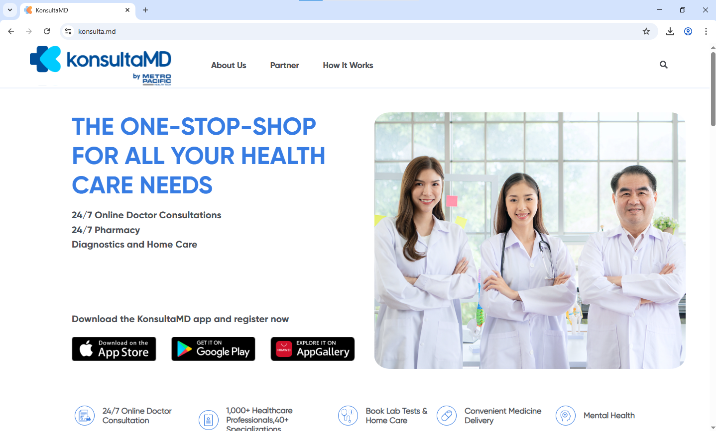

Figure 1. **KunsultaMD**

KonsultaMD, a telemedicine platform by Metro Pacific Health Tech Corp. (mWell), is designed to provide accessible healthcare services, including mental health consultations, to be more accessible for Filipinos. Users can consult licensed doctors and mental health professionals directly via video calls, chat, or phone consultations from the comfort of their own homes. Users can book appointments with psychiatrists and psychologists, access prescription services, and receive follow-up care through the online platform's built-in system.

KonsultaMD also promotes mental health literacy through the availability of educational content and health articles, allowing users to store their medical records online for enhanced continuity of care. The application also tackles geographical limitations by linking patients from isolated towns with doctors and psychiatrists in major cities, making quality mental health services more reachable across the country.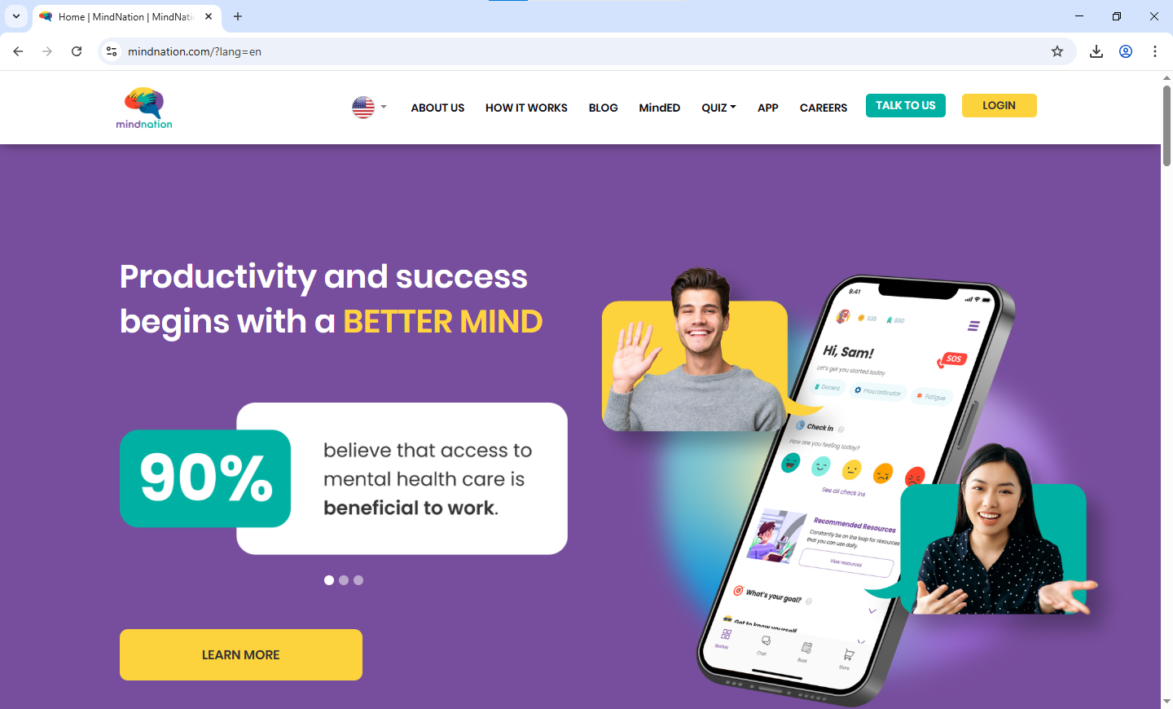

Figure 2. **MindNation**

MindNation is a Southeast Asian mental health platform that was specifically designed to extend culturally adapted psychological assistance and therapy services to Southeast Asian communities. MindNation users are linked to licensed therapists and counselors who are attuned to the specific cultural environment and mental health issues of Filipino and other Southeast Asian communities. Users have access to individual therapy, group counseling, and mental health screenings through secure video calls or messaging apps. MindNation encourages mental wellness through content that is culturally appropriate, such as articles and resources discussing stigma and cultural hindrances to help-seeking. The platform also offers low costs and sliding scale fees, promoting professional mental health treatment for individuals across varying socioeconomic segments in the area.

**Foreign**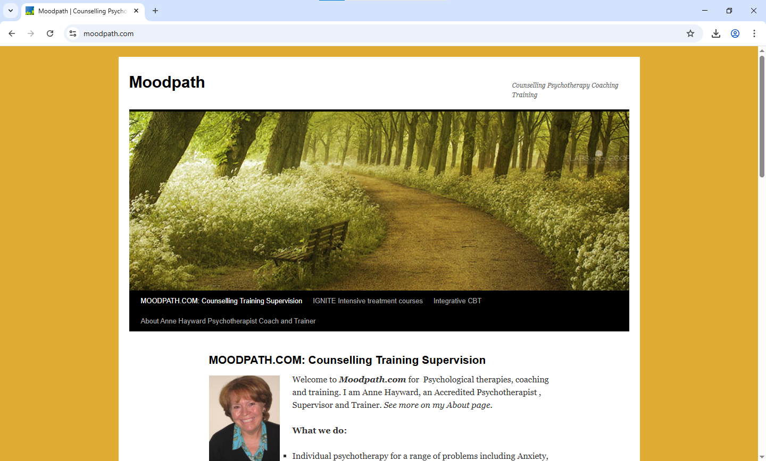

Figure 3. **Moodpath**

Moodpath is an unfunded company based in Berlin (Germany), founded in 2016 by Mark Goering and Felix Frauendorf. Designed mental health screening app intended to assist users in tracking their psychological health and detecting potential signs of depression and anxiety. Users are requested to fill out short daily questionnaires based on scientifically established questions, monitoring mood patterns, sleep, and emotional states over time. Users are given personalized feedback and comprehensive mental health reports that can be passed along to healthcare professionals for more informed consultations. Moodpath promotes self-awareness through the provision of psychoeducational information and cognitive-behavioral therapy-based coping strategies. The app also offers users the ability to export their mood data for clinical use, bridging the gap between self-monitoring and professional mental health care in European healthcare systems.

Figure 4. **Wysa**

Wysa is a mental health chatbot app created by Wysa Ltd., co-founded by Jo Aggarwal and Ramakant Vempati, to deliver instant emotional care and therapy chat using artificial intelligence. The application gives users 24/7 access to a conversational AI based on evidence-based therapeutic methods, such as cognitive behavior therapy and mindfulness exercises, to manage anxiety, depression, and stress. People can have guided chats, do breathing exercises, and use mood-tracking features with full anonymity. Wysa also fosters emotional resilience by training users with coping mechanisms and self-helpers through conversational interventions and tailored advice. The app also features easy escalation to human professionals when necessary, with an end-to-end hybrid model that combines AI accessibility with professional human interaction for comprehensive mental health services.

### Comparative Analysis

A comparative matrix highlights the similarities and differences among products, services, or even more complex and abstract concepts such as strategies and ideas. The matrix assists in organizing and categorizing the elements under comparison. The features and characteristics of each component are assessed based on a specific set of criteria or standards, allowing for an easy identification of their advantages and disadvantages, which in turn helps in making decisions.

**COMPETITORS ANALYSIS**

Table 1: **Competitors Analysis**

| **Related Studies** | **Features** | **Limitations** | **Platform Details** | **Support** |
| --- | --- | --- | --- | --- |
| **Name:** KonsultaMD  **Url:** [**https://konsultamd.com/**](https://konsultamd.com/)  **Proponent(s)**: KonsultaMD  Team A sister company of Medicard Philippines | 1. Video/chat consultations with licensed professionals  2. Prescription services  3. Digital medical records  4. 24/7 availability | 1. Requires internet connectivity  2. Limited to consultation format  3. May lack personalized screening tools | Mobile and Web App | Professional healthcare providers  Insurance partnerships  Customer support |
| **Name:** MindNation  **Url:**<https://mindnation.com/>  **Proponent(s):** MindNation Team  Southeast Asia-focused mental health platform | 1. Culturally sensitive therapy  2. Licensed therapists for SEA communities  3. Group counseling options  4. Affordable pricing models | 1. Limited geographical reach  2. Dependency on therapist availability  3. May not include AI-powered screening | Mobile and Web App | Licensed therapists  Cultural specialists  Community support |
| **Name:** Moodpath  **Url:**<https://moodpath.com/>  **Proponent(s):** Aurora Health (Germany) | 1. Daily mood assessments  2. Depression and anxiety screening  3. Clinical-grade reports  4. Data export for healthcare providers | 1. Limited to mood tracking  2. Primarily focused on depression/anxiety  3. May lack comprehensive intervention features | Mobile App | Clinical validation  Healthcare provider integration  European privacy compliance |
| **Name:** Wysa  **Url:**<https://wysa.io/>  **Proponent(s):** Jo Aggarwal and Ramakant Vempati  Wysa Ltd. | 1. AI-powered chatbot conversations  2. 24/7 availability  3. Anonymous interactions  4. Evidence-based therapeutic techniques  5. Human therapist escalation | 1. AI limitations in complex cases  2. May lack personalized screening protocols  3. Potential privacy concerns with AI data | Mobile and Web App | AI-powered support  Human therapist backup  Global accessibility |

**Comparative Matrix**

A comparison matrix emphasizes the similarities and differences between products, services, or even more intangible and abstract entities like strategies and ideas. The matrix helps to organize and classify the items being compared. A specific set of criteria is applied to evaluate characteristics and features of each item, which makes the advantages and disadvantages easy to recognize, and thus enable informed and wise decision-making.

**COMPARATIVE MATRIX**

Table 2: **Comparative Matrix**

|  | **KonsultaMD** | **MindNation** | **Moodpath** | **Wysa** | **FriendofMind** | **Percentage** |
| --- | --- | --- | --- | --- | --- | --- |
| Educational Content | ✔ | ✔ | ✔ | ✔ | ✔ | 100% |
| Personalized Assessment |  |  | ✔ | ✔ | ✔ | 60% |
| Cultural Sensitivity Features |  | ✔ |  |  | ✔ | 40% |
| Crisis Intervention Support | ✔ | ✔ |  | ✔ | ✔ | 80% |
| Anonymous Support |  |  | ✔ | ✔ | ✔ | 60% |
| 24/7 Availability | ✔ |  |  | ✔ | ✔ | 60% |
| User Feedback System |  |  |  |  | ✔ | 20% |
| Encouragement Wall |  |  |  |  | ✔ | 20% |
| **Total** | 42% | 42% | 42% | 71% | 100% |  |

# CHAPTER III DESIGN AND METHODOLOGY

## Research Design

### Methodology

This study adopts a developmental research design to guide the systematic creation, development, and refinement of *FriendofMind*, a digital mental health screening and support platform for Filipino users. This design is ideal for projects that focus on producing practical and usable systems while incorporating evaluation at various stages. As defined by Seels and Richey (1994), developmental research involves "the systematic study of designing, developing, and evaluating instructional programs, processes, and products that must meet criteria of internal consistency and effectiveness."

This approach enables researchers to iteratively develop the platform based on literature, user needs, and continuous feedback, ensuring the tool is functional, user-friendly, and contextually relevant.

### Flow of the Study

Figure 5. **Flow of the Study**

The flow of the study outlines the systematic approach taken in developing ***FriendofMind***, a personalized mental health screening and support platform. The process begins with the identification of both functional and non-functional requirements. Functional requirements include essential system features such as user registration and authentication, screening tools (PHQ-9, GAD-7, PSS), feedback and rating functions, mental health directories, mood tracking, and personalized activity suggestions. Non-functional requirements focus on system performance, scalability, security, and privacy, which are critical in ensuring that users feel safe and confident when using the platform.

In the **analysis phase**, the team examined necessary data requirements, form and policy structures, and system constraints to ensure ethical and technical compliance. UX and UI design principles were applied to create a user-friendly interface, while data security and storage strategies were implemented to safeguard sensitive information. This stage also involved outlining the data reporting functions and preparing documentation for system development and user guidance.

The **design phase** followed, beginning with data modeling, structure definition, and visual representations through ERD and DFD. A high-fidelity prototype was developed to visualize the system's structure and interface. Security mechanisms, including access control, authentication, encryption, and firewalls, were integrated to support secure user interaction. The system's client-server architecture was finalized, and the dashboard was designed to provide users with insights, reports, and feedback. A user manual and survey questionnaire were also prepared for evaluation purposes.

During the **testing phase**, the system was evaluated using ISO25010 standards, which cover usability, reliability, functionality, and portability. Screen testing, both manual and automated, was conducted to ensure operational effectiveness. Selected users also participated in user testing to provide feedback on the actual usability.

During the testing phase, the platform was deployed under the working name *"FriendofMind*." The deployment stage marked the official release of the system for public interaction, targeting Filipino students and young professionals. In the final **review phase**, the team closely monitored system behavior, user feedback, and emerging issues to ensure stability and continuous improvement. Observed errors and usability insights informed ongoing updates, reinforcing the system's reliability and relevance to its intended users.

### Research Environment

This study will be conducted through an online setting to ensure broad accessibility and reach among potential respondents across various areas. The researchers aim to gather participants from different communities by disseminating a Google Forms survey through online channels such as social media, group chats, and messaging platforms. This approach ensures that individuals from diverse backgrounds and locations can participate in the study, regardless of their specific barangay. To ensure comprehension and inclusivity, the survey will be made available in both English and Bisaya, accommodating native speakers and promoting accurate responses. Conducting the research in an online environment also supports confidentiality and convenience, which are crucial in addressing the sensitive topic of mental health.

### Respondents

The participants of this study will consist of 50 individuals selected through a convenience sampling technique. These respondents will be composed of Filipino community members who are accessible through online platforms. Convenience sampling, as described by Rahi (2017), involves selecting participants who are readily available and willing to participate, which is suitable for the exploratory nature of this research. The target population includes individuals who may be experiencing stress, anxiety, or other mental health concerns but have limited access to professional support. Their insights will help validate the need for a digital mental health screening and support tool and guide its development to ensure relevance and responsiveness to their needs.

### Research Instrument

The primary instrument used in this research is a structured online survey questionnaire developed using Google Forms. The questionnaire was crafted to align with the study's objectives and is structured in two main stages:

**Stage 1** focuses on understanding the participants' mental health awareness, current coping mechanisms, and openness to digital tools. It includes multiple-choice questions to gather quantitative data and open-ended items to capture personal insights, challenges, and suggestions. This stage aims to assess the common mental health issues faced by the respondents and validate the necessity of the proposed platform.

**Stage 2** will involve usability testing of the proposed solution. A high-fidelity prototype of the Friend of Mind platform will be presented to a select group of respondents. Through interactive elements, participants will explore its features, such as digital self-assessment tools, guided resources, and access to confidential support options. After interacting with the prototype, respondents will complete a follow-up questionnaire focused on usability, accessibility, perceived usefulness, and suggestions for improvement..

### Research Procedure

The data-gathering procedure will be implemented in two distinct stages. Initially, the researchers will distribute a transmittal message explaining the purpose and ethical considerations of the study, followed by the survey link. The **Stage 1** questionnaire will be disseminated online and will run for a specific period until the target number of responses is reached. This stage is designed to identify existing mental health concerns, user expectations, and current limitations in accessing support systems.

Once the data from Stage 1 is analyzed, the researchers will proceed to **Stage 2**, wherein participants will be given access to a clickable, interactive prototype of the FriendofMind platform. Respondents will be asked to navigate the prototype and provide feedback through usability testing and structured follow-up surveys. This process will gather qualitative data that will guide iterative design improvements before proceeding to full-scale development.

Throughout the process, the researchers will ensure that participation is voluntary, confidential, and based on informed consent. The data collected will be used solely for research and development purposes, with no identifying personal information gathered.

#### Data Gathering

Data was collected through online means to ensure inclusivity, accessibility, and participant comfort. The researchers used structured Google Forms surveys for both the initial needs assessment and the post-prototype usability testing. These surveys included:

* Closed-ended items (e.g., Likert scales, multiple-choice) for statistical analysis.
* Open-ended questions to collect in-depth feedback, user suggestions, and specific pain points.

Distribution was conducted via social media and messaging platforms to reach a diverse range of Filipino participants, primarily students and young professionals. The use of both English and Bisaya versions ensured cultural relevance and clarity for the target population.

#### Treatment of Data

Quantitative data from the surveys were organized using statistical software such as Microsoft Excel or Google Sheets. Descriptive statistics (e.g., frequencies, means) were computed to summarize key variables, such as user perception of usability and openness to digital mental health tools.

Qualitative responses were subjected to thematic analysis to identify recurring patterns, user sentiments, and actionable insights. These qualitative themes supported the refinement of platform features and helped guide ethical and culturally sensitive design decisions.

All collected data were anonymized before analysis to ensure participant privacy and were stored securely in password-protected digital environments accessible only to the research team

#### Ethical Considerations

The researchers are committed to maintaining the highest ethical standards throughout the research process. Given the sensitivity of mental health topics, all participants will be treated with respect, and their rights to privacy and confidentiality will be strictly protected.

Participation will be voluntary, and informed consent will be obtained after the study's purpose, objectives, procedures, and potential impacts have been clearly explained. This ensures that participants fully understand their involvement and can make informed decisions.

All personal information collected through surveys or interviews will be securely stored and used solely for research purposes. No identifiable data will be disclosed without consent.

Special care will be taken to safeguard the well-being of participants, recognizing their potential vulnerability. Support resources will be available should any discomfort arise.

Participant selection will be fair and inclusive, with equal distribution of any risks and benefits. Transparency will be upheld in explaining how data will be collected, analyzed, and applied in platform development.

A zero-tolerance policy on research misconduct will be enforced. Only the researchers, advisers, and authorized experts will have access to study data to ensure integrity and accountability. These considerations reflect the researchers' dedication to conducting an ethical, respectful, and credible study in the development of **FriendofMind**.

### **Software Engineering Methodology**

Figure 6. **Agile Research Methodology**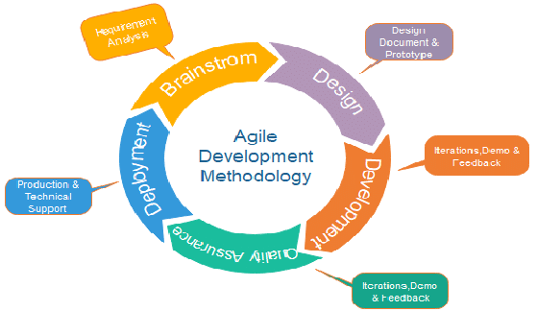

**Agile Research Methodology**

This study adopts the Agile Research Methodology, which emphasizes an iterative, adaptive, and user-centered approach. The Agile methodology allows for continuous feedback and flexibility—key elements when dealing with sensitive and evolving areas, such as mental health.

*FriendofMind* is designed to address the changing needs of individuals seeking mental health support, particularly within the Philippine context. By applying agile principles, the research will remain responsive to insights from users, mental health professionals, and stakeholders throughout the development process.

The methodology facilitates the identification and prioritization of features and functionalities most relevant to users, including personalized screening tools, support options, and educational resources. These elements will be iteratively tested and refined based on feedback from target users, including students, young professionals, and community members.

The study will also examine the opportunities and challenges associated with enhancing mental health awareness and access through digital platforms. Using agile cycles, the development of *FriendofMind* will focus on usability, inclusivity, and effectiveness—ensuring the platform not only screens users accurately but also connects them with appropriate support systems promptly.

Finally, the agile approach will reinforce *FriendofMind's* commitment to user empowerment, privacy, and community involvement. By continuously iterating based on real-world use and feedback, the project aims to deliver a scalable and impactful mental health solution that evolves alongside user needs and mental health trends.

### **Planning/Conception-Initiation Phase**

#### Business Model Canva

Figure 7. **Business Model Canvas**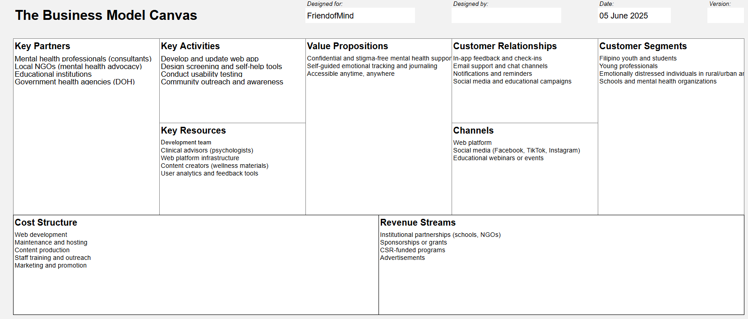

The Business Model Canvas (BMC) for **Friend of Mind** provides a structured snapshot of how the proposed platform will create, deliver, and capture value within the Philippine mental health ecosystem. At the core of the model is a **value proposition** that offers confidential, stigma-free mental-health support through self-guided screening, mood-tracking, and journaling tools—accessible to users anytime and anywhere. This value is targeted at four primary **customer segments**: Filipino youth and students, young professionals, individuals experiencing emotional distress in both rural and urban settings, and institutions such as schools or mental health organizations seeking a scalable support resource.

To realize this value, the venture depends on several interlocking components. **Key activities** center on continuous web-app development, the design of evidence-based screening and self-help modules, iterative usability testing, and community outreach that normalizes help-seeking behavior. These activities draw upon **key resources**—notably a multidisciplinary development team, clinical advisors (psychologists), robust hosting infrastructure, content creators for wellness materials, and analytics tools for real-time user feedback. Strategic **key partners** bolster these resources: mental-health professionals who validate content, local NGOs that champion advocacy, educational institutions that offer pilot environments, and the Department of Health, which can lend policy alignment and reach.

Friend of Mind sustains **customer relationships** through in-app feedback loops, email or chat support, push notifications, and ongoing educational campaigns across social media. These relationships are nurtured through **channels** that include the web platform itself, popular social networks (such as Facebook, TikTok, and Instagram), and periodic webinars or outreach events. Financial feasibility is addressed in the **cost structure**, which is dominated by web development, server hosting, content production, staff training, and marketing. Correspondingly, **revenue streams** are projected to arise from institutional partnerships with schools and NGOs, sponsorships or grant funding, corporate social responsibility programs, and carefully curated advertising. Taken together, the BMC demonstrates a coherent pathway for Friend of Mind to deliver culturally relevant digital mental-health support while maintaining operational sustainability.

#### **Program Workflow**

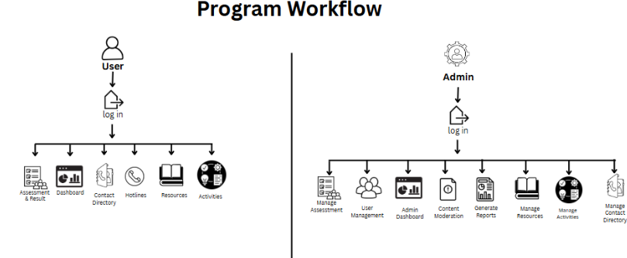

Figure 8. **Program Workflow**

The program workflow of the **FriendofMind** platform illustrates a two-user system composed of the **User** and **Admin** roles, each with specific access and responsibilities that contribute to the goal of promoting early mental health support. In a research approach, this structure is essential for demonstrating how functionalities are divided based on user type, ensuring an organized and purpose-driven development process aligned with the study's objectives.

Upon logging in, users are granted access to core features such as **mental health assessments and results**, **dashboard visualization**, **contact directories for professionals**, **mental health hotlines**, **educational resources**, and **supportive activities** designed to promote well-being. This workflow emphasizes **early detection** and **user engagement**, aligning with the study's intention to offer a proactive and user-centered mental health support tool.

The **Admin** side of the platform manages the system's content and users. After login, the admin can oversee **user management**, handle **assessment modules**, access the **admin dashboard** for analytics, perform **content moderation**, **generate reports**, and manage **resources**, **activities**, and **the contact directory**. This division of tasks supports the backend operations of the platform, ensuring that the data provided to users is accurate, safe, and consistently updated based on feedback and system reviews.

Overall, the program workflow reflects a logical and efficient flow of operations tailored to both end-user needs and administrative maintenance, thereby fulfilling the project's research goal of building a responsive and sustainable mental health screening and support platform.

#### **V**alidation Board

Figure 9. **Stage 1 Validation Board**

Figure 10. **Stage 2 Validation Board**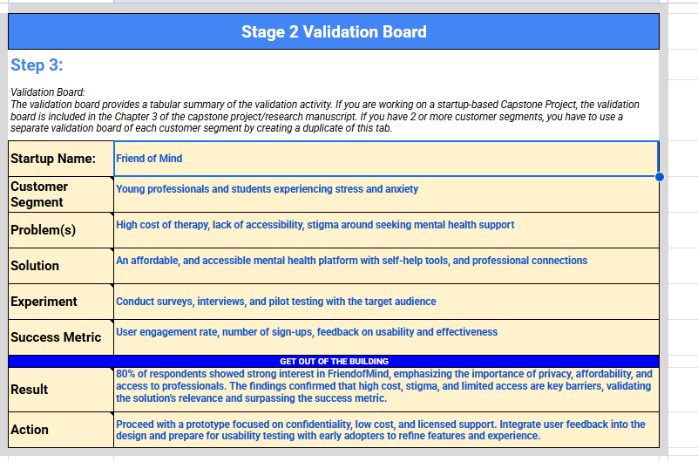

The validation boards presented in Stages 1 and 2 provide a structured overview of the iterative validation process for the FriendofMind platform, following a research-based approach to product development.

In Stage 1, the study identified burned-out young professionals as the primary customer segment, hypothesizing that they face challenges related to stress and require a stigma-free mental health platform. Through surveys and interviews with corporate employees, 70% confirmed experiencing work-related stress and an interest in digital mental health tools, validating the initial hypothesis. As a result, the action taken was to proceed with prototyping a solution that addresses the user-identified needs for privacy and accessibility.

In Stage 2, the target group was expanded to include both young professionals and students experiencing stress and anxiety. The study examined barriers, including cost, stigma, and limited access to support. The proposed solution was an affordable and accessible mental health platform offering self-help tools and professional support. With 80% of respondents affirming the need for such a solution and emphasizing features like privacy and affordability, the findings further validated the platform's direction. The next step focused on refining the prototype and aligning it with the validated needs of its users.

Together, these validation stages confirm that the FriendofMind platform is both needed and relevant, and they provide a clear foundation for evidence-based design and development.

#### Business Road Map

Figure 11. **Business Road Map**

The *FriendofMind* roadmap spans five phases, starting with planning and research to define features and user needs in Cebu City. It moves into system design and prototyping, followed by the development of core modules like property listings, lease uploads, and an AI chatbot. Integration and testing come next to ensure full functionality, ending with user evaluation, documentation, and final presentation.

#### Functional Decomposition Diagram

Figure 12. **Function Decomposition Diagram**

The Functional Decomposition Diagram illustrates the hierarchical structure of the FriendofMind platform by breaking down major functionalities into smaller, manageable sub-functions. It serves as a blueprint that clarifies how each module contributes to the system's overall purpose

Core modules include User Account Management, Mental Health Screening, Personalized Support Recommendations, Mood Tracking, Encouragement Wall, and Resource Directory Management. Each is further divided into tasks such as system navigation, adaptive question delivery, result interpretation, content filtering, community moderation, and data export.

This structured breakdown provides a clear view of how the platform operates, supports efficient module development, and ensures cohesive workflows across both user and admin interfaces.

#### Gantt Chart

The Gantt chart serves as a project management tool that visually outlines the timeline and sequential flow of activities involved in developing the *FriendofMind* system. It utilizes horizontal bars to represent the estimated start and completion dates of each task, including phases such as planning, analysis, design, development, testing, and evaluation. This visual representation facilitates efficient time management, resource allocation, and identification of task dependencies. By providing a clear overview of the project schedule, the Gantt chart ensures that each activity aligns with the intended project milestones and overall research timeline (Grant, 2022).

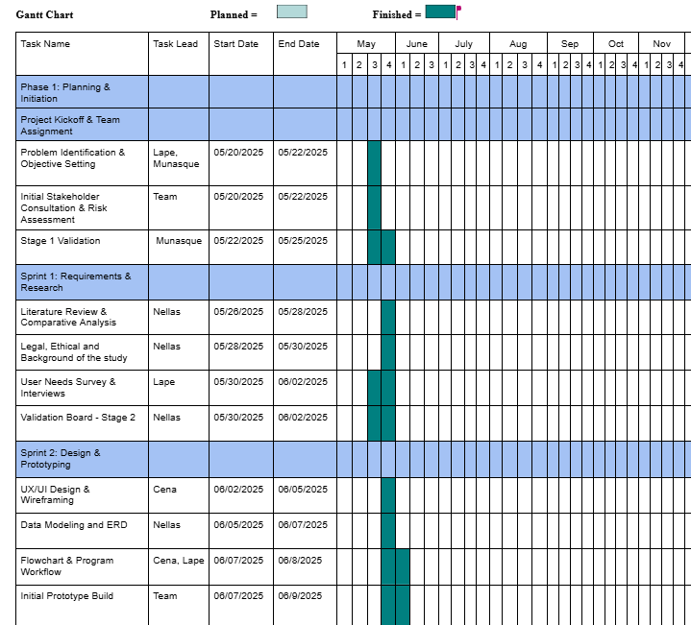

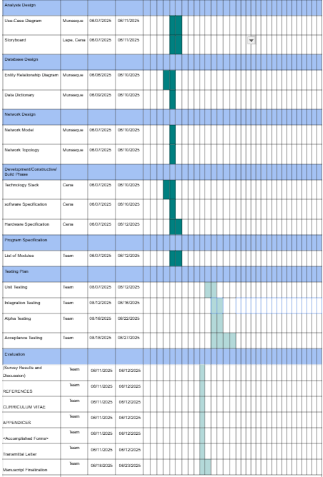

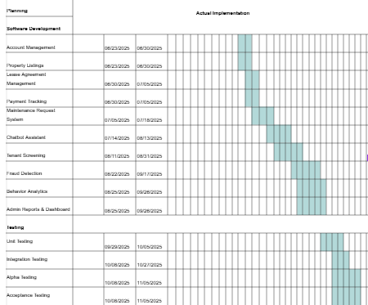

Figure 13.  **Grant Chart**

### Analysis-design Phase

In the analysis-design phase of *FriendofMind*, the team identified system requirements through use case diagrams, focusing on key features like mental health screening, mood tracking, and access to resources. Storyboards mapped user flows such as taking assessments, receiving recommendations, and browsing support content. A detailed ERD and data dictionary defined the platform's data structure, while a logical network design ensured secure, efficient access. This phase provided a clear blueprint for building a user-friendly, reliable mental health support platform.

#### Use Case Diagram

Figure 14. User Use Case Diagram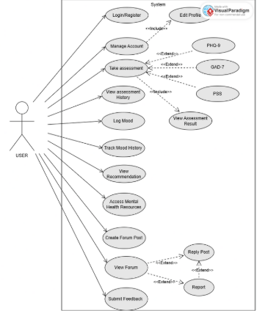

The *FriendofMind* User Use Case Diagram highlights five core functions designed to support users' mental well-being. The Assessment Feature allows users to take mental health screenings, while the Result Viewer displays their scores and corresponding assessment/severity levels. The Recommendation Module provides users with tailored next steps or coping suggestions. The Create/Reply Forum allows users to Discuss and respond to a certain topic. Lastly, users can Access Mental Health Resources, such as wellness articles, hotline directories, and guided activities aimed at fostering self-care and awareness.

Figure 15. Admin Use Case Diagram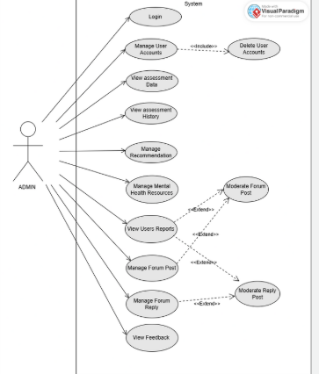

The Admin Use Case Diagram for *FriendofMind* outlines key backend management functions. Admins can **Manage User Accounts**, **Oversee Assessment Results**, and **Monitor Platform Activity** to ensure data integrity and user safety. They also can **Manage Resources**, such as uploading helpful content and updating directory information. Additional responsibilities include **Generating Reports**,

#### Storyboard

A storyboard is a visual planning tool that uses a sequence of images or illustrations to outline the flow of a movie, animation, motion graphic, or any interactive media. It helps visualize the storyline, structure, and transitions ahead of production.

Figure 16. **Landing Page**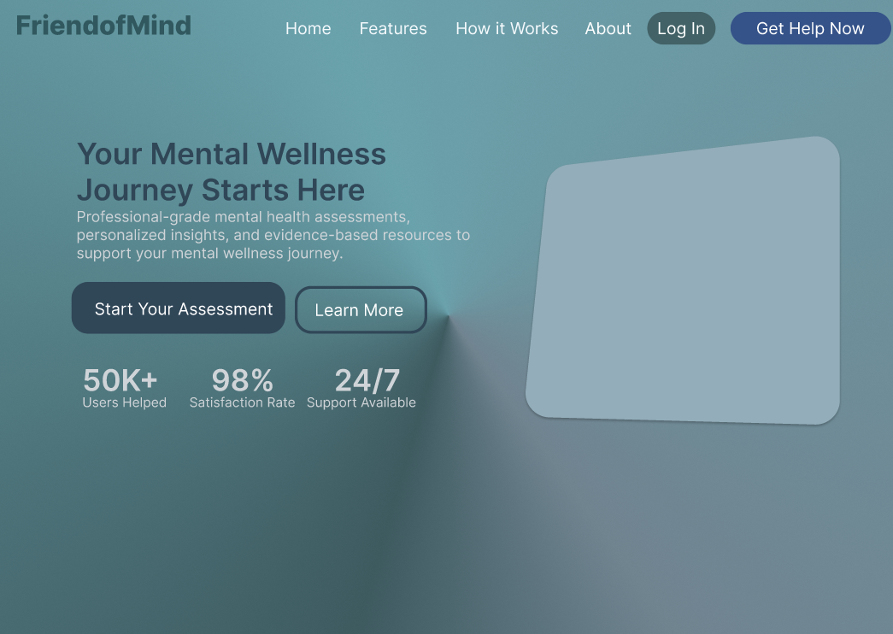

The landing page of *FriendofMind* offers users a welcoming interface to initiate assessments, view results, and access mental health resources. Designed for ease of use and emotional comfort, it reflects the platform's goal of promoting early mental health awareness and guiding users toward appropriate support.

Figure 17. **User Dashboard**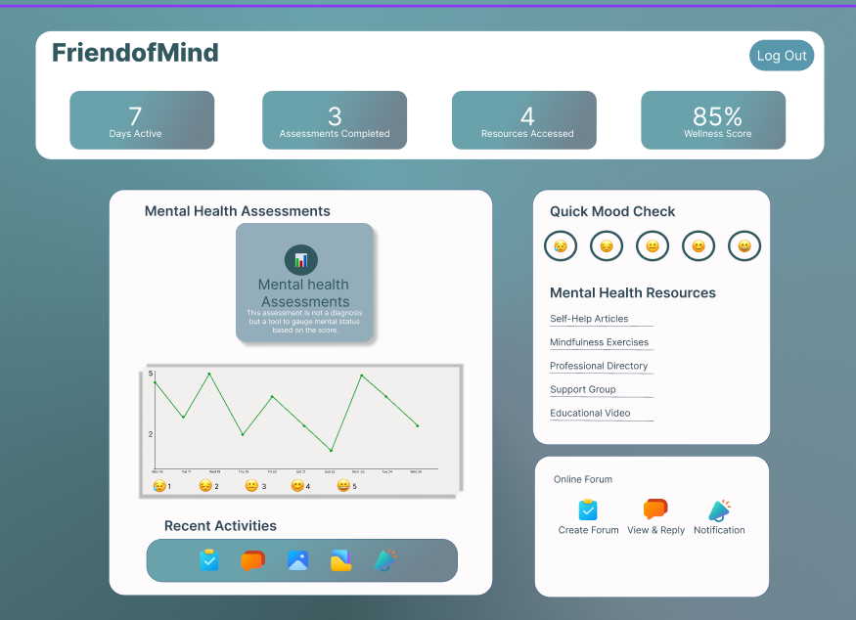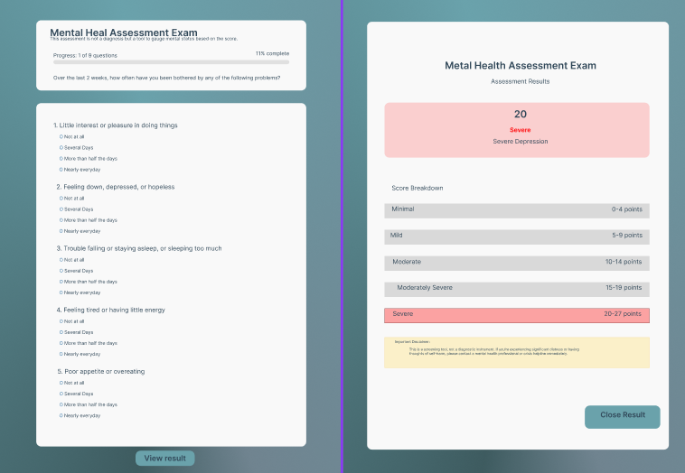

Figure 18. **Assessment and Result Page**

Figure 19. **Admin Dashboard**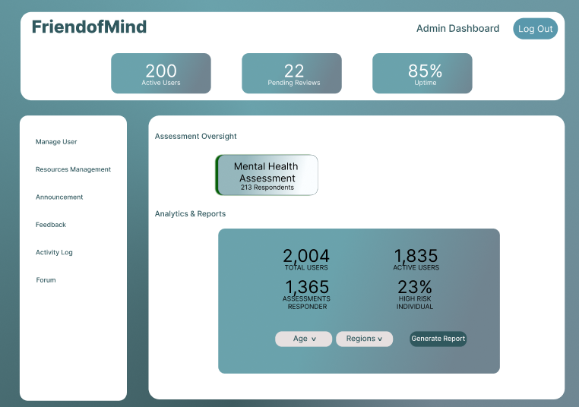

This figure illustrates the Admin Dashboard of the Friend of Mind platform. It highlights essential administrative functionalities, including user management, resource moderation, posting announcements, viewing feedback, and accessing activity logs. The dashboard also provides assessment oversight for tools like PHQ-9, GAD-7, and PSS, enabling administrators to track engagement. Additionally, it offers analytics and reporting features, with filter options for age and region, supporting data-driven decision-making and system monitoring.

### Database Design

#### Entity-Relationship Diagram Relationship Diagram

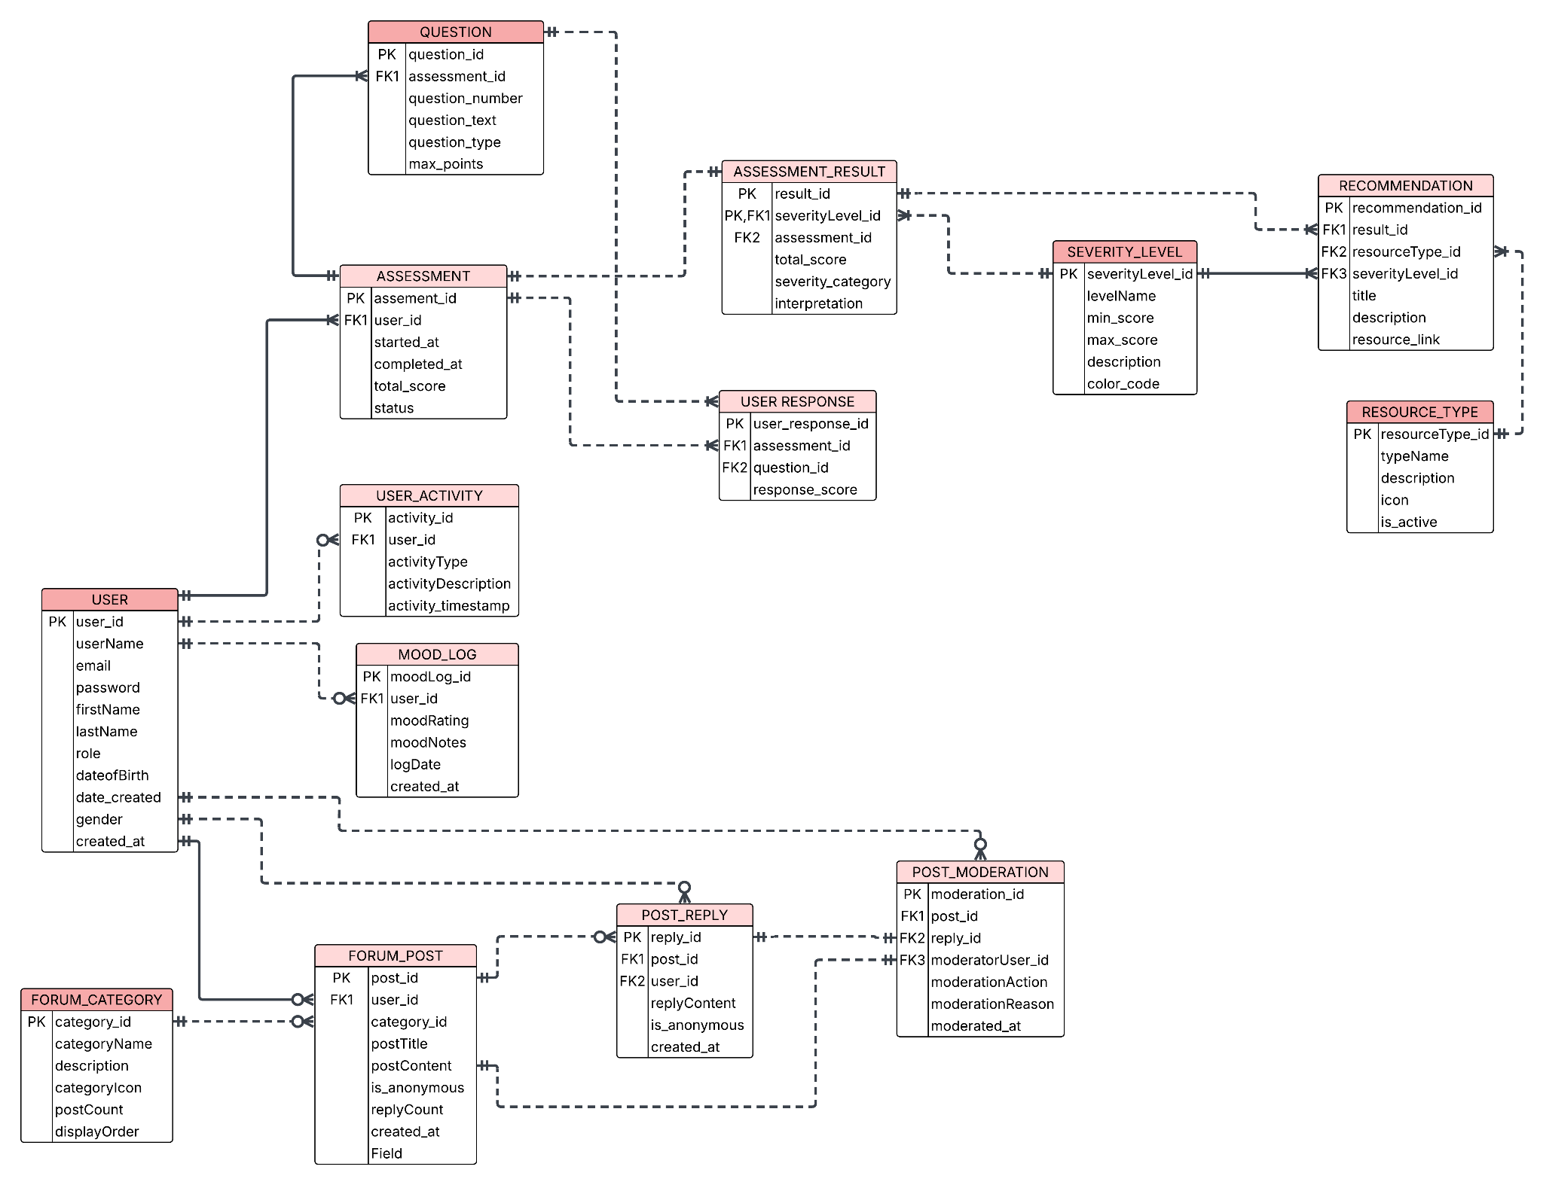

5

Figure 20.  **ERD Relationship Diagram**

An Entity Relationship Diagram (ERD) is a visual tool used in system design to represent the structure of a database, showing how data is organized and how different components are related. In this research project, the ERD outlines the system's backend structure for a mental health support platform. It illustrates how users interact with various features such as assessments, activity and mood tracking, and forum participation. The diagram ensures that data flow and relationships are logically designed to support accurate screening, meaningful insights, and user engagement—making it a crucial part of the system's development.

#### Data Dictionary

A data dictionary is a comprehensive reference that defines and organizes data elements within a specific domain. It outlines entities, their attributes, data types, formats, and relationships, supporting consistent terminology and structure. By facilitating efficient data retrieval and management, a well-designed data dictionary enhances data understanding, integrity, and sharing across systems and users.

Table 3. **Data Dictionary**

| Table Name | Attribute Name | Contents | Type | Format | Range | Required | PK or FK | FK Reference Tables |
| --- | --- | --- | --- | --- | --- | --- | --- | --- |
| User | user_id | Unique identifier for user | Integer | N/A | N/A | Yes | PK | - |
| User | userName | User’s userName | String | Text | 1–100 | Yes |  | - |
| User | email | User’s email address | String | Email | N/A | Yes |  | - |
| User | password | Encrypted password | String | Encrypted | N/A | Yes |  | - |
| User | firstName | User’s First Name | String |  |  | Yes |  |  |
| User | lastName | User’s Last Name |  |  |  |  |  |  |
| User | role | User role (admin/user) | String | Text | Fixed | Yes |  | - |
| User | dateofBirth | User’s Date of birth | String |  |  | Yes |  |  |
| User | date_created | Date of account creation | Date | YYYY-MM-DD | N/A | Yes |  | - |
| User | gender | User’s Gender | String | N/A | N/A | Yes | N/A | - |
| User | created_at | Timestamp of account creation | Timestamp | Date | YYYY-MM-DD  HH:MM:SS | N/A | Yes | - |
| Assessment_Type | assessmentType_id | Unique identifier for assessment type | Integer | N/A | N/A | Yes | PK | - |
| Assessment_Type | assessmentName | Name of the assessment | String | N/A | N/A | Yes | N/A | - |
| Assessment_Type | assessmentCode | Short code for the assessment | String | N/A | N/A | Yes | N/A | - |
| Assessment_Type | description | Detailed description of the assessment | Text | N/A | N/A | No | N/A | - |
| Assessment_Type | total_questions | Total number of questions in assessment | Integer | N/A | 1-100 | Yes | N/A | - |
| Assessment_Type | max_score | Maximum possible score for assessment | Integer | N/A | 1-100 | Yes | N/A | - |
| Assessment_Type | is_active | Whether the assessment is currently active | Boolean | True/False | N/A | Yes | N/A | - |
| Question | question_id | Unique identifier for each question | Integer | N/A | N/A | Yes | PK | - |
| Question | assessmentType_id | Reference to assessment type | String | Text | N/A | Yes | FK | Asessment_Type |
| Question | question_number | Sequential number of question | Integer | N/A | 1-100 | Yes | N/A | - |
| Question | question_text | The actual question text | Text | N/A | N/A | Yes | N/A | - |
| Question | question_type | Type of question | Integer | N/A | N/A | Yes | N/A | - |
| Question | max_points | Maximum points for possible question | Integer | N/A | 1-10 | Yes | N/A | - |
| Assessment | assessment_id | Unique Id for Assessment | Integer | N/A | N/A | Yes | PK | - |
| Assessment | user_id | Reference to user who took assessment | Integer | N/A | N/A | Yes | FK | User |
| Assessment | assessmentType_id | Reference to assessment Type | Integer | N/A | N/A | Yes | FK | Assessment |
| Assessment | started_at | When the assessment was started | Timestamp | YYYY-M-DD  HH:MM:SS | N/A | Yes | N/A | - |
| Assessment | completed_at | when the assessment was completed | Timestamp | YYYY-M-DD  HH:MM:SS | N/A | No | N/A | - |
| Assessment | total_score | Total score achieved in assessment | Integer | N/A | 0-1000 | No | N/A | - |
| Assessment | status | Status of the assessment | String | N/A | in_progress, completed, abandoned | Yes | N/A | - |
| User_Response | user_response_id | Unique User response ID | Integer | N/A | N/A | Yes | PK | - |
| User_Response | assessment_id | Reference to assessment | Integer | N/A | N/A | Yes | FK | Assessment |
| User_Response | question_id | Reference to question | Integer | N/A | N/A | Yes | FK | Question |
| User_Response | response_score | Score given for this response | Integer | N/A | 0-10 | Yes |  | - |
| Severity_Level | severityLevel_id | Unique Severity Level ID | Integer | N/A | N/A | Yes | PK | - |
| Severity_Level | levelName | Name of the severity Level | String | N/A | N/A | Yes | N/A | - |
| Severity_Level | min_score | Minimum score for this severity level | Integer | N/A | 0-1000 | Yes | N/A | - |
| Severity_Level | max_score | Maximum score for this severity level | Integer | N/A | 0-1000 | Yes | N/A | - |
| Severity_Level | description | Description of severity Level meaning | Text | N/A | N/A | No | N/A | - |
| Severity_Level | color_code | Color code for UI display | String | Hex Format | #00000  #FFFFFF | No | N/A | - |
| Assessment_result | result_id | Unique result ID | Integer | N/A | N/A | Yes | PK | - |
| Assessment_result | assessment_id | Reference to assessment | Integer | N/A | N/A | Yes | FK | Assessment |
| Assessment_result | severityLevel_id | Reference to severity level | Integer | N/A | N/A | Yes | FK | Severity_Level |
| Assessment_result | total_score | Total score from assessment | Integer | N/A | 0-1000 | Yes | N/A | - |
| Assessment_result | severity_category | Category severity determined | String | N/A | N/A | Yes | N/A | - |
| Assessment_result | interpretation | Detailed interpretation of results | Text | N/A | N/A | No | N/A | - |
| Resource_Type | resourceType_id | Unique Resource Type ID | Integer | N/A | N/A | Yes | PK | - |
| Resource_Type | typeName | Name of resource type | String | N/A | N/A | Yes | N/A | - |
| Resource_Type | description | Description of the resource type | Text | N/A | N/A | No | N/A | - |
| Resource_Type | icon | Icon identifier for UI display | String | N/A | N/A | No | N/A | - |
| Resource_Type | is_active | Whether resource type is currently active | Boolean | True/False | N/A | Yes | N/A | - |
| Recommendation | recommendation_id | Unique Recommendation Id | Integer | N/A | N/A | Yes | PK | - |
| Recommendation | result_id | Reference to assessment result | Integer | N/A | N/A | Yes | FK | Assessment_Result |
| Recommendation | resourceType_id | Reference to resource type | Integer | N/A | N/A | Yes | FK | Resource_Type |
| Recommendation | severityLevel_id | Reference to severity level | Integer | N/A | N/A | Yes | FK | Severity_Level |
| Recommendation | title | Title of the recommendation | String | N/A | N/A | Yes | N/A | N/A |
| Recommendation | description | Detailed description of recommendation | Text | N/A | N/A | No | N/A | N/A |
| Recommendation | resource_link | URL or link to the resource | String | URL format | N/A | No | N/A | N/A |
| Mood_Log | moodLog_id | Unique mood log ID | Integer | N/A | N/A | Yes | PK | - |
| Mood_Log | user_id | Reference to user | Integer | N/A | N/A | Yes | FK | User |
| Mood_Log | moodRating | Numeric mood rating | Integer | N/A | 1-10 | Yes | N/A | - |
| Mood_Log | moodNotes | Optional notes about the mood | Text | N/A | N/A | No | N/A | - |
| Mood_Log | logDate | Date of the mood log entry | Date | YYYY-MM-DD | N/A | Yes | N/A | - |
| Mood_log | created_at | Timestamp when log was created | Timestamp | YYYY-MM-DD  HH:MM:SS | N/A | Yes | N/A | - |
| User_Activity | activity_id | Unique activity ID | Integer | N/A | N/A | Yes | PK | - |
| User_Activity | user_id | Reference to user | Integer | N/A | N/A | Yes | FK | User |
| User_Activity | activityType | Type of activity performed | String | N/A | N/A | Yes | N/A | - |
| User_Activity | activityDescription | Description of the activity | Text | N/A | N/A | No | N/A | - |
| User_Activity | activity_timestamp | When the activity occurred | Timestamp | YYYY-MM-DD  HH:MM:SS | N/A | Yes | N/A | - |
| Forum_Category | category_id | Unique category ID | Integer | N/A | N/A | Yes | PK | - |
| Forum_Category | categoryName | Name of the forum category | String | N/A | N/A | Yes | N/A | - |
| Forum_Category | description | Description of category purpose | Text | N/A | N/A | No | N/A | - |
| Forum_Category | categoryIcon | Icon identifier for the category | String | N/A | N/A | No | N/A | - |
| Forum_Category | postCount | Number of posts in this category | Integer | N/A | 0-99999 | Yes | N/A | - |
| Forum_Category | displayOrder | Order for displaying categories | Integer | N/A | 1-100 | Yes | N/A | - |
| Forum_Post | post_id | Unique post ID | Integer | N/A | N/A | Yes | PK | - |
| Forum_Post | user_id | Reference to user who created post | Integer | N/A | N/A | Yes | FK | User |
| Forum_Post | category_id | Reference to forum category | Integer | N/A | N/A | Yes | FK | Forum_Category |
| Forum_Post | postTitle | Title of the forum post | String | N/A | N/A | Yes | N/A | - |
| Forum_Post | postContent | Content/body of the post | Text | N/A | N/A | Yes | N/A | - |
| Forum_Post | is_anonymous | Whether the post is anonymous | Boolean | True/False | N/A | Yes | N/A | - |
| Forum_Post | replyCount | Number of replies to this post | Integer | N/A | 0-99999 | Yes | N/A | - |
| Forum_Post | created_at | When the post was created | Timestamp | YYYY-MM-DD  HH:MM::SS | N/A | Yes | N/A | - |
| Post_Reply | reply_id | Unique reply ID | Integer | N/A | N/A | Yes | PK | - |
| Post_Reply | post_id | Reference to forum post | Integer | N/A | N/A | Yes | FK | Forum_Post |
| Post_Reply | user_id | Reference to user who replied | Integer | N/A | N/A | Yes | FK | User |
| Post_Reply | replyContent | Content of the reply | Text | N/A | N/A | Yes | N/A | - |
| Post_Reply | is_anonymous | Whether the reply is anonymous | Boolean | True/False | N/A | Yes | N/A | - |
| Post_Reply | created_at | When the reply was created | Timestamp | YYYY-MM-DD  HH:MM:SS | N/A | Yes | N/A | - |
| Post_Moderation | moderation_id | Unique moderation ID | Integer | N/A | N/A | Yes | PK | - |
| Post_Moderation | post_id | Reference to post being moderated | Integer | N/A | N/A | No | FK | Forum_POST |
| Post_Moderation | reply_id | Reference to reply being moderated | Integer | N/A | N/A | No | FK | Post_Reply |
| Post_Moderation | moderatorUser_id | Reference to moderator user | Integer | N/A | N/A | Yes | FK | User |
| Post_Moderation | moderationAction | Type of moderation action taken | String | N/A | N/A | Yes | N/A | - |
| Post_Moderation | moderationReason | Reason for the moderation action | Text | N/A | N/A | No | N/A | - |
| Post_Moderation | moderated_at | When moderation action was taken | Timestamp | YYYY-MM-DD  HH:MM:SS | N/A | Yes | N/A | - |

### Network Design

Network design refers to the process of organizing how a computer network will be established and operated. This involves assessing, outlining, and gaining a clear understanding of the network setup. It includes the layout of cables, IP addresses, and network devices. A network's system design defines how data will be transmitted and fulfills communication requirements. Typically, network design is illustrated using a network diagram, which acts as a guide for the physical setup of the network.

HTTP (Hypertext Transfer Protocol) is a set of rules used for transferring files over the internet, such as text, images, audio, video, and other types of multimedia. When a user opens a web browser, HTTP is used in the background. It is classified as an application-layer protocol that works with the TCP/IP protocol suite. HTTP is preferred because it supports the management of user sessions.

#### Network Model

Figure 21. **Network Model**

The network model offers a flexible approach to representing objects and their relationships within a database system. Its distinctive feature lies in how it represents data: it uses a graph format, where objects are depicted as nodes, and the relationships between them are shown as edges. Unlike hierarchical or relational models, this format does not follow a strict tree or table structure (Bachman, 1969).

#### Network Topology

Figure 22. **Star Network Topology**

*FriendofMind* adopts a **star topology** to ensure centralized, stable, and efficient communication between its system components. In this setup, all devices connect to a central hub—the *FriendofMind* web server—which manages interactions between users, the admin panel, and the system database. Users access the platform through the internet. This lets them perform screenings, view results, and explore mental health resources in real-time. This setup improves system reliability, simplifies maintenance, and supports secure data flow. It ensures a smooth user experience across all platform features.

### Development/Construction/Build Phase

#### Technology Stack

Figure 23. **Technology Stack**

The appropriate tools for the front-end and back-end are critical to creating the desired system. The diagram above shows the specific tools the researcher will use to create the proposed system. These instruments are vital to molding the system’s behavior.

#### Software Specification

Program Specification represents the outcome of a program and how the program works. It will help to understand the process of implementing a system. One of these processes is the list of a module, which allows the research to know the next step. 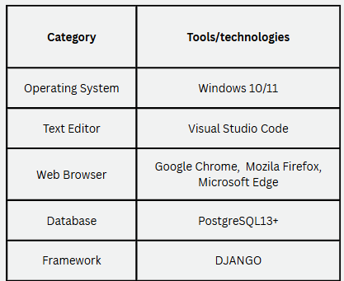

Figure 24. **Software Specification**

#### **Hardware Specification**

The hardware specifications are the physical objects that allow the system to exist and define the technical descriptions required for the proposed system to operate effectively and efficiently. Due to numerous technological advancements and user requirements, hardware components change frequently. Consequently, these specifications are typically used as a guide rather than an absolute norm.

Figure 25. **Hardware Specification**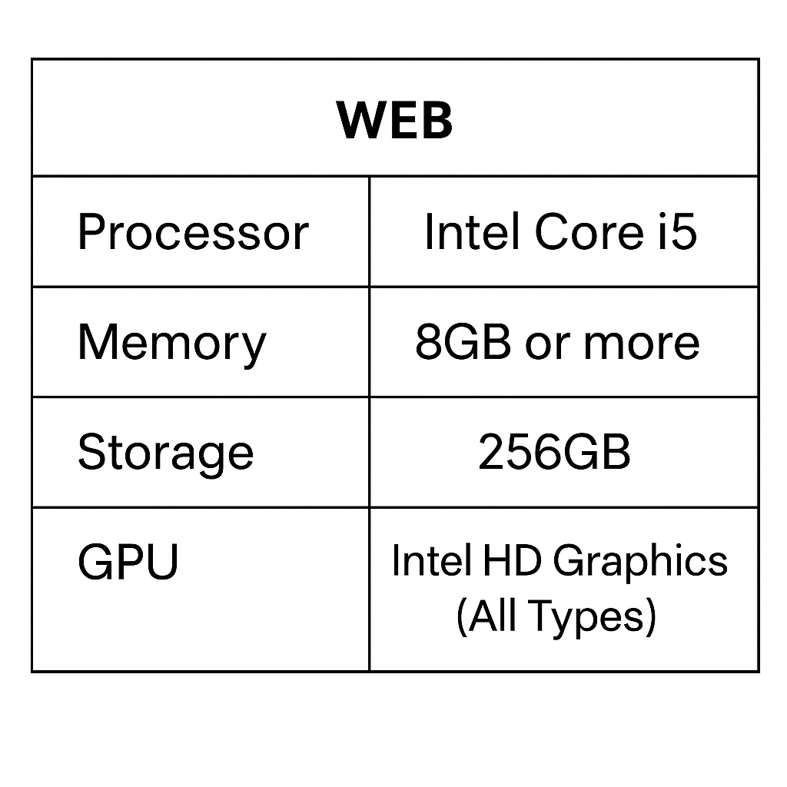

#### Program Specification

The program specification describes the expected outcomes and key functions of the system. It provides practical steps—like outlining the necessary modules—to help researchers plan their next moves effectively.

##### **List of Modules**

Table 4. **List of Module**

| Programmer | Modules | User | Admin |
| --- | --- | --- | --- |
| Cena | Account Management |  |  |
|  | 1. Register Account | ✔ | ✔ |
|  | 2. Login/Logout | ✔ | ✔ |
|  | 3. Edit Profile | ✔ | ✔ |
|  | 4. Edit Address | ✔ | ✔ |
| Lape | 5. Delete Account |  | ✔ |
|  | 6. Disable Account |  | ✔ |
| Muñasque | 7. Add Account |  | ✔ |
|  | Points | 1 | 1 |
| Lape & Muñasque | Mental Health Screening |  |  |
|  | 1. Take PHQ-9, GAD-7, PSS | ✔ |  |
|  | 2. View Screening Results | ✔ | ✔ |
|  | 3. Provide Suggestions/Resources |  | ✔ |
|  | Points | 1 | 1 |
| Cena & Muñasque | Self-Help & Learning Tools |  |  |
|  | 1. Access Articles & Videos | ✔ | ✔ |
|  | 2. Bookmark/Save Content | ✔ |  |
|  | 3. Add/Edit Content |  | ✔ |
|  | 4. Report Inaccurate Info | ✔ | ✔ |
|  | Points | 1 | 1 |
| Nellas | Notifications |  |  |
|  | 1. View Notifications | ✔ | ✔ |
|  | 2. Reminder Alerts | ✔ | ✔ |
|  | Points | 1 | 1 |
| Lape & Muñasque | Feedback & Usability |  |  |
|  | 1. Submit Feedback | ✔ |  |
|  | 2. Analyze Feedback |  | ✔ |
|  | 3. System Improvement Suggestions |  | ✔ |
|  | 4. Users Forum | ✔ |  |
|  | Points | 1 | 1 |
| Number of Unit per User | | 5 | 5 |
| Total Number of Module | | 10 | |

### Testing Plan

The testing plan serves as a comprehensive document that outlines the strategic approach for evaluating the performance, reliability, and functionality of the *RentEase* platform prior to its deployment. It defines the testing objectives, scope, schedule, resource allocation, required tools, and expected deliverables. This plan functions as a structured guide for organizing, executing, and monitoring the testing activities throughout the development life cycle. Its primary purpose is to ensure that the system meets the predefined requirements and operates as intended under various conditions. By systematically identifying and addressing potential issues, the testing plan contributes to the delivery of a stable and high-quality system that aligns with user needs and expectations.

#### Unit Testing

Unit testing evaluates individual components of an application to ensure they function correctly. Typically performed early by developers, this process isolates code segments to identify and address issues efficiently. By verifying each unit before integration, unit testing enhances overall code reliability and fosters confidence in the system’s functionality.

Table 5. **Unit Testing**

| **Module Name** | **Unit Name** | **Date Tested** | **Test Case ID** | **Test Case Description** | **Expected Result** | **Actual Result** | **Remarks** |
| --- | --- | --- | --- | --- | --- | --- | --- |
| Account Management | Create Account |  | TC-AM-001 | User registers with required fields | Account created and redirected to verification screen |  |  |
| Account Management | Verify Email |  | TC-AM-002 | User clicks verification link sent via email | Account marked as verified |  |  |
| Account Management | Login to Account |  | TC-AM-003 | User logs in with valid credentials | Redirected to appropriate user dashboard |  |  |
| Mental Health Screening | Start Screening |  | TC-MS-001 | User clicks “Start Screening” | Screening questionnaire is displayed |  |  |
| Mental Health Screening | Submit Screening Answers |  | TC-MS-002 | User answers questions and submits | Personalized result and suggestions displayed |  |  |
| Mood Tracker | Add Daily Mood |  | TC-MT-001 | User logs a mood entry for the day | Mood saved and visual tracker updated |  |  |
| Mood Tracker | View Mood History |  | TC-MT-002 | User navigates to history tab | Mood logs displayed in graphical form |  |  |
| Encouragement Wall | Post Message |  | TC-EW-001 | User submits an encouragement post | Message appears on public wall |  |  |
| Encouragement Wall | Moderate Message (Admin) |  | TC-EW-002 | Admin reviews reported post | Message is removed or retained |  |  |
| Support Recommendations | View Recommendations |  | TC-SR-001 | After screening, user clicks on recommendations | Relevant articles, tools, and resources are listed |  |  |
| Directory Access | View Contact Directory |  | TC-CD-001 | User opens directory tab | Lists of free/paid professionals and hotlines displayed |  |  |
| Notification System | Receive Screening Reminder |  | TC-NT-001 | Notification triggers at set time | User receives in-app or email reminder |  |  |
| Admin Dashboard | Manage Users |  | TC-AD-001 | Admin clicks on “Manage Users” | List of registered users is shown |  |  |
| Admin Dashboard | View Reports |  | TC-AD-002 | Admin selects date range to generate report | Downloadable PDF/CSV generated |  |  |

#### 

#### Integration Testing

Table 6. **Integration Testing**

| **Test Case ID** | **Module 1** | **Integration Process** | **Module 2** | **Pre-condition** | **Expected Outcome** | **Result** | **Remarks** |
| --- | --- | --- | --- | --- | --- | --- | --- |
| ITC-001 | User Registration | Submit user data and verify | User Database | User inputs all required registration fields | User account is created and stored in the database | Pass | Tested through `/register/`; verified entry via Django admin Users list |
| ITC-002 | Email Verification | Send and confirm verification link | Authentication Module | User has completed registration | User is marked as verified; access to system is unlocked | Pass | Django console email backend shows link; hitting URL sets status |
| ITC-003 | Dashboard Login | Authenticate and redirect | User Dashboard | User is verified and inputs correct credentials | User is redirected to their personalized dashboard | Pass | Checked via `/login/`; redirect + greeting confirmed |
| ITC-004 | Mental Health Assessment | Submit answers and fetch results | Screening Result Generator | User is logged in and submits valid responses | Assessment result is computed and stored | Pass | Flow exercised at `/screening/phq9/take/`; DB tables populated |
| ITC-005 | Screening Result | Display interpreted outcome | Recommendation Engine | Assessment has been completed | Personalized resources and tips are generated | Pass | Verified result screen shows thresholds + recommendations |
| ITC-006 | Recommendation Engine | Load filtered content | Resource Directory Module | User has a valid result profile | User is shown relevant articles, activities, and professionals | Pass | Confirmed `/resources/recommended/` reflects recent PHQ-9 outcome |
| ITC-007 | Mood Tracker | Record mood and trends | User History Log | User accesses daily tracker | Entry is saved and visual trends are updated on dashboard | Pass | Entry visible in tracker history and dashboard trend graph |
| ITC-008 | Encouragement Wall | Submit, display, and moderate posts | Admin Panel | Post is submitted by a logged-in user | Post appears publicly or awaits approval depending on settings | Pass | New post appears in queue; auto-approved setting showed it on wall |
| ITC-009 | Contact Directory | View or contact professionals | Hotline & Professional Data | User is logged in | Directory of free and paid professionals is displayed with hotlines | Pass | `/resources/professionals/` displays seeded data + quick-call links |
| ITC-010 | Admin Panel | View system metrics | Reports & Analytics | Admin is logged in and has access rights | Dashboard displays user stats, engagement data, and system logs | Pass | `/admin-dashboard/` charts populated; log table matches recent actions |
| ITC-011 | Admin Content Manager | Approve or reject wall posts | Encouragement Wall Module | Admin has pending posts for review | Status of posts is updated and reflected in wall | Pass | Moderated via `/admin/core/encouragementpost/`; wall updated after action |
| ITC-012 | Feedback Form | Submit user feedback | Feedback Database | User submits comment or rating | Feedback is stored and retrievable by admin | Pass | `/feedback/submit/` hit; admin list shows new record |
| ITC-013 | Forgot Password | Validate and reset password | User Account Module | User provides correct recovery email | Password reset link is sent; new password updates successfully | Pass | Console backend email contains reset link; post-reset login confirmed |

#### Alpha Testing

Alpha testing was conducted in a controlled development environment to evaluate the initial functionality and usability of the *FriendofMind* platform. This phase involved internal testing by the developers and selected participants, such as classmates and academic advisers, to identify system bugs, logical errors, and interface issues. Core features—including the PHQ-9, GAD-7, and PSS screening tools, mood tracking, self-help resources, and the mental health directory—were tested to ensure reliability and responsiveness. Feedback gathered during this phase guided further refinements prior to broader user testing.

Table 7. **Alpha Testing**

| Test Criteria | Poor | Fair | Good | VeryGood |
| --- | --- | --- | --- | --- |
| Graphical User Interface (GUI) | | | | |
| **Consistency:** The extent to which the user interface maintains uniform style and uses consistent icons and elements throughout. |  |  |  |  |
| **Reusability:** The use of familiar and reusable UI components, such as buttons, text fields, and checkboxes, to enhance user experience. |  |  |  |  |
| **Forgiveness & Tolerance:** The interface’s ability to provide informative messages or confirmation prompts before critical actions and allow users to undo or redo errors. |  |  |  |  |
| **Simplicity:** The Clarity and uncluttered nature of the GUI design, with easy-to-understand buttons and screens. |  |  |  |  |
| **Readability:** The Use Of Suitable Color Pairings, font sizes, and styles to ensure effortless reading for the target audience. |  |  |  |  |
| **Clarity:** The Clarity and Conciseness Error messages, help text, and warnings use easy-to-understand language. |  |  |  |  |
| **Flexibility:** The ability for users to personalize preferences through settings, such as adjusting font size or color themes. |  |  |  |  |
| **User-Friendliness:** The overall user-friendliness of the GUI design, including helpful and non-offensive messages. |  |  |  |  |
| System Performance | | | | |
| **Conformance to Requirements:** The System's ability to deliver all the features and functionalities documented in the requirements document. |  |  |  |  |
| **Conformance to Objectives:** The system’s success in meeting all the specific objectives outlined for its development. |  |  |  |  |
| **Operational Efficiency:** The Efficiency Of The entire system, including the speed of transactions and the absence of delays. |  |  |  |  |
| **Security:** The system’s security measures include authentication of login credentials and validation of input parameters. |  |  |  |  |
| **User Data Control:** The ability for registered users to manage and control their private information within the system. |  |  |  |  |

## REFERENCES

**Alqahtani, F., & Orji, R. (2020).** Insights from user reviews to improve mental health apps. *Health Informatics Journal, 26*(3), 2042–2066. https://doi.org/10.1177/1460458219896492

**Bakker, D., Kazantzis, N., Rickwood, D., & Rickard, N. (2016).** Mental health smartphone apps: Review and evidence-based recommendations for future developments. *JMIR Mental Health, 3*(1), e7. https://doi.org/10.2196/mental.4984

**Davis, F. D. (1989).** Perceived usefulness, perceived ease of use, and user acceptance of information technology. *MIS Quarterly, 13*(3), 319–340. https://doi.org/10.2307/249008

**Inquirer. (2023, May 2).** Gen Z Filipinos have more ‘mind health’ issues than global average—report. *Inquirer Technology*. https://technology.inquirer.net/136319/gen-z-filipinos-have-more-mind-health-issues-than-global-average

**Lally, J., Tully, J., & Samaniego, R. M. (2019).** Mental health services in the Philippines. *BJPsych International, 16*(3), 62–64. https://doi.org/10.1192/bji.2018.34

**Martinez, A. G., Dimataga, R. L. A., Flores, M. A. P., & Sy, M. C. S. (2021).** Addressing the mental health of Filipino youth: A call for action. *Journal of Global Health Reports, 5*, e2021030. https://doi.org/10.29392/001c.30255

**Republic Act No. 11036. (2018).** Mental Health Act of the Philippines. Retrieved from https://lawphil.net/statutes/repacts/ra2018/ra_11036_2018.html

**Seels, B. B., & Richey, R. C. (1994).** Instructional technology: The definition and domains of the field. http://ci.nii.ac.jp/ncid/BA26396862

**World Health Organization. (2022).** Digital mental health interventions: Implementation strategies for scale-up and sustainability. Retrieved from <https://www.who.int/publications/i/item/9789240052702>

## CURRICULUM VITAE

## 

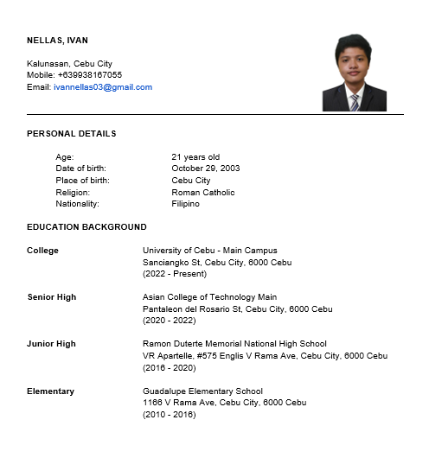

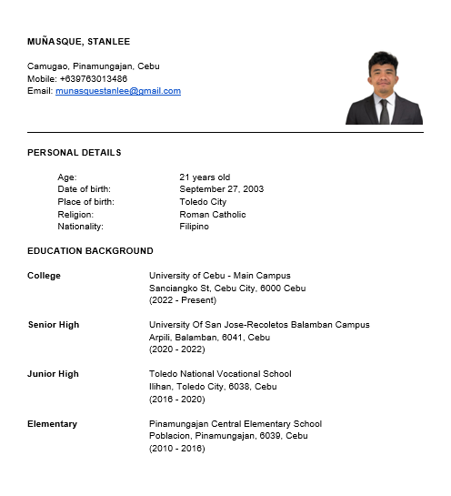

## APPENDICES

## Accomplished Forms

### Appendix A: Research Working Title Approval Form

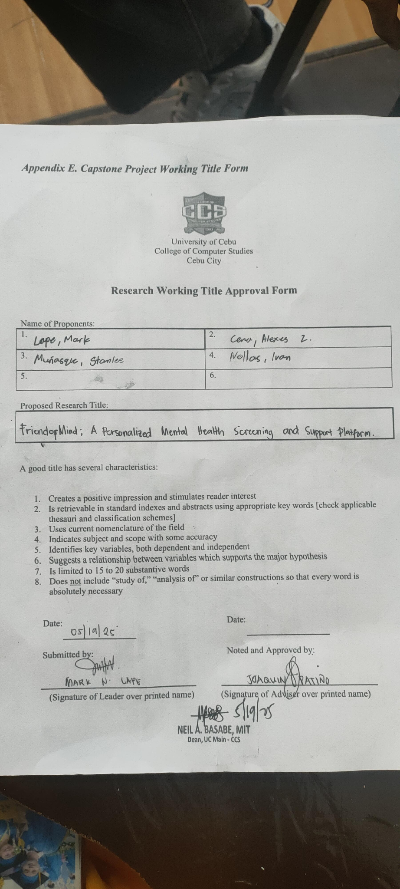

### Appendix B: Capstone Project Team Composition Form

### Appendix C: Oath of Confirmation

### 

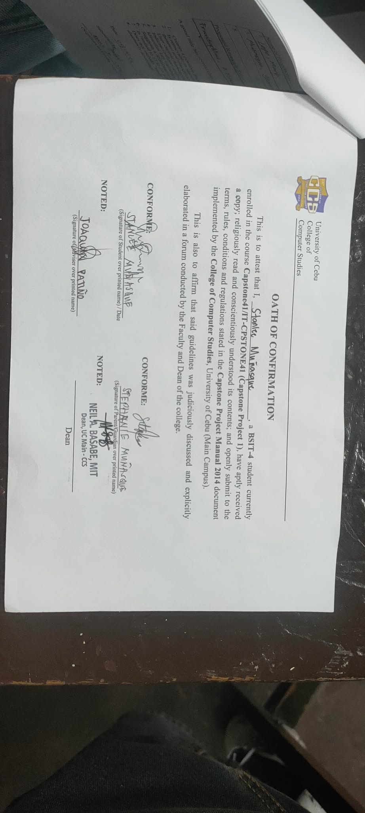

### Appendix D: List of Modules

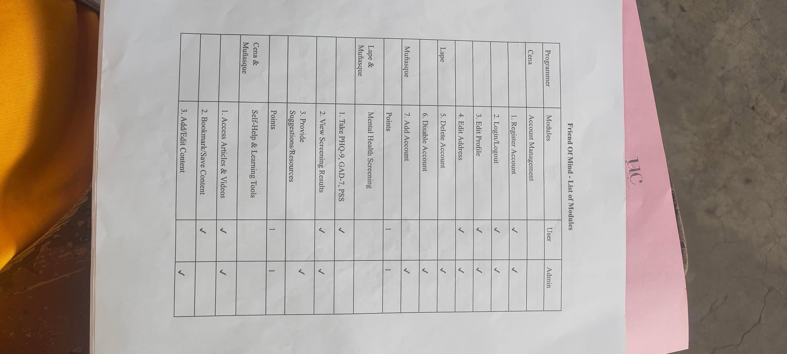

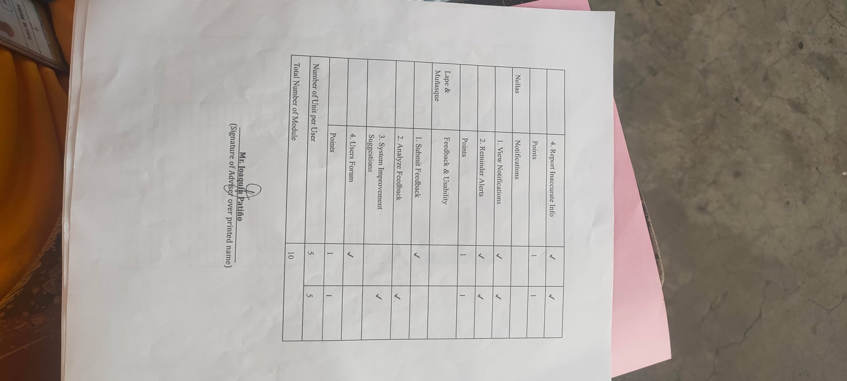

### Appendix E: Capstone30 Consultation Log Form

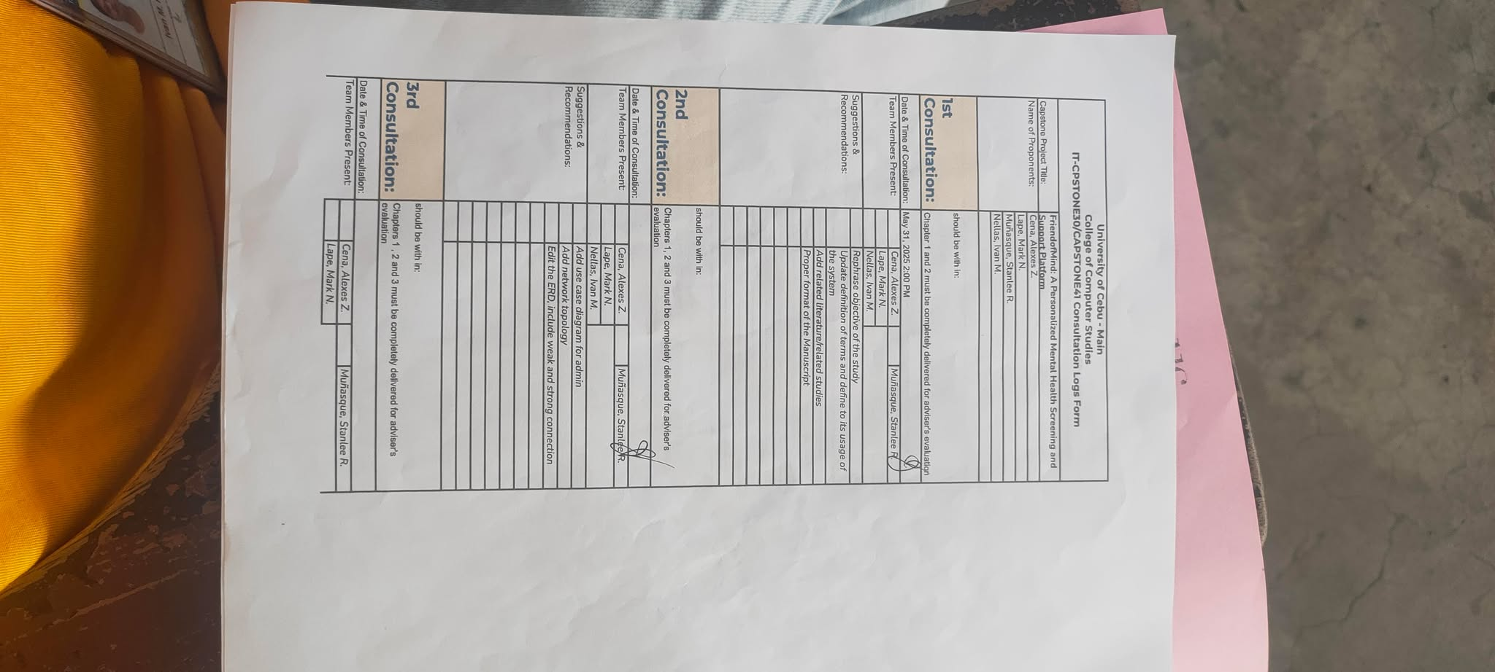

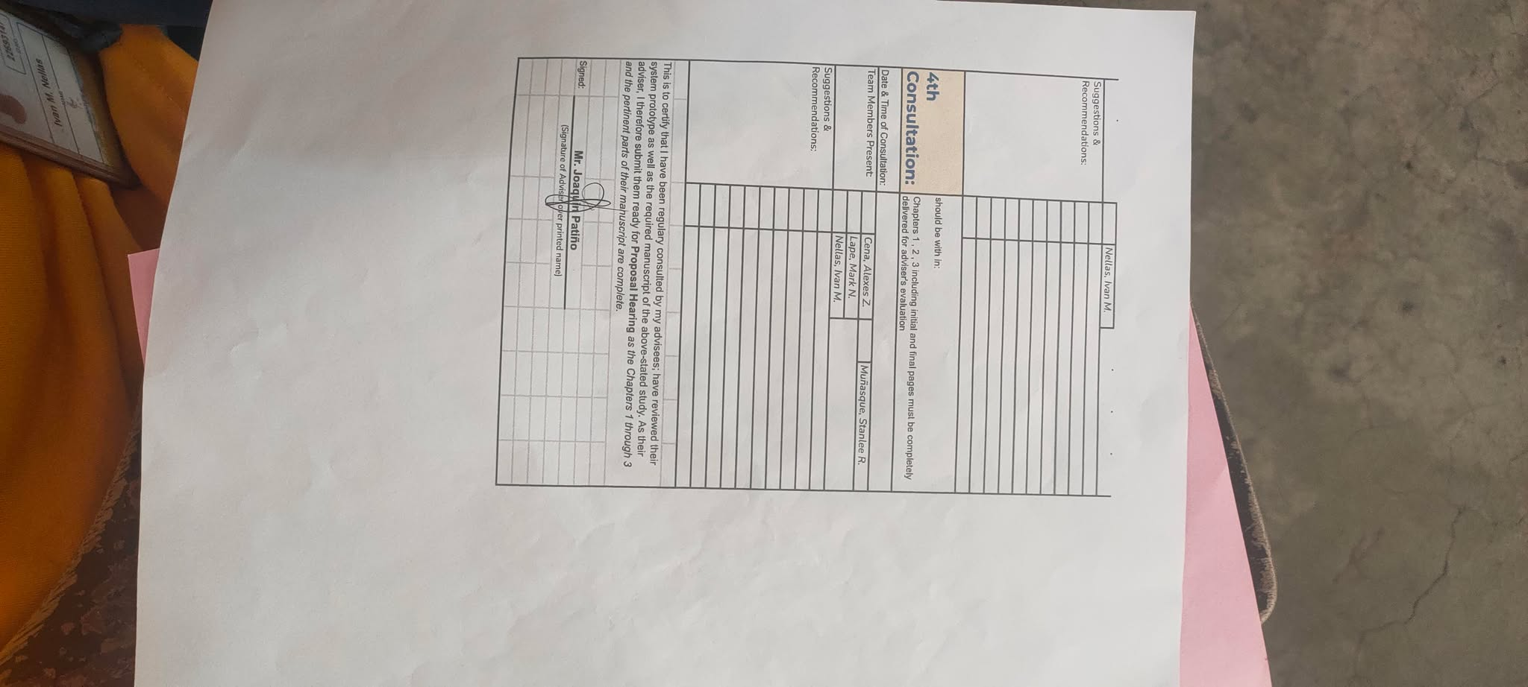

### Appendix F: Transmittal Letter

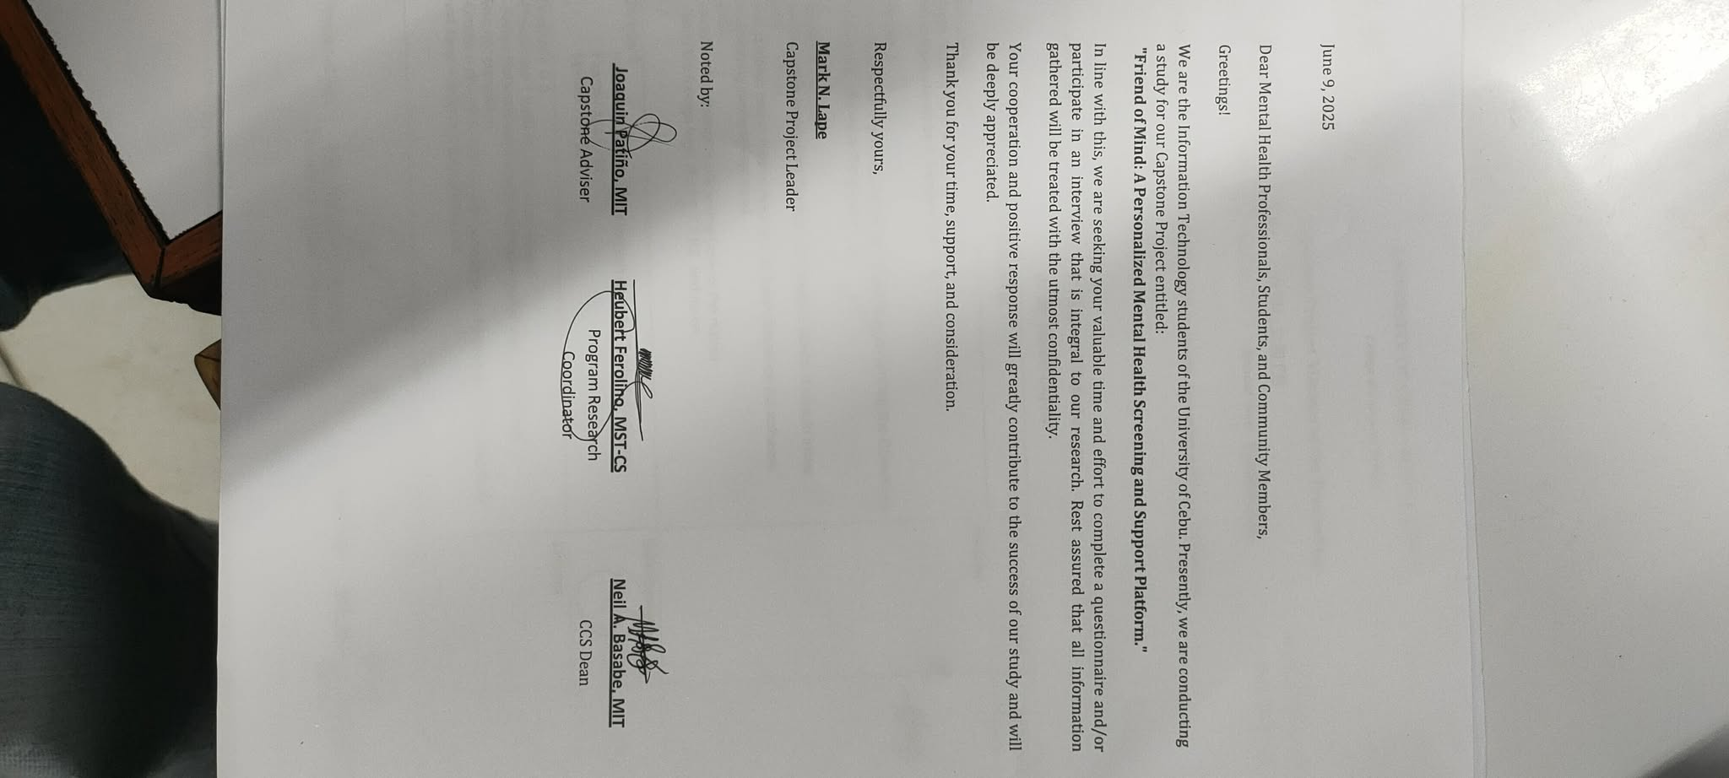

### Appendix G: Survey Questionnaire

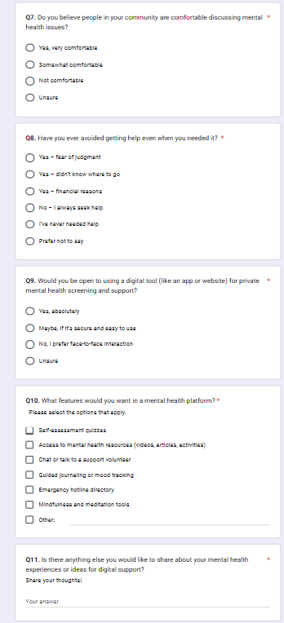

### Appendix H: Grammar and Plagiarism Form 19

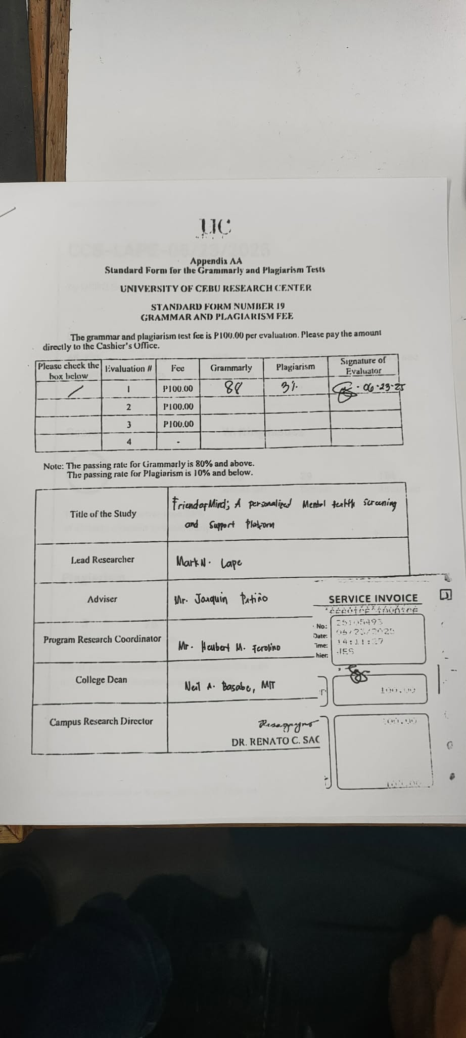

### Appendix I: Grammar and Plagiarism Result

### Appendix J: Capstone Project Minutes of the Proceedings

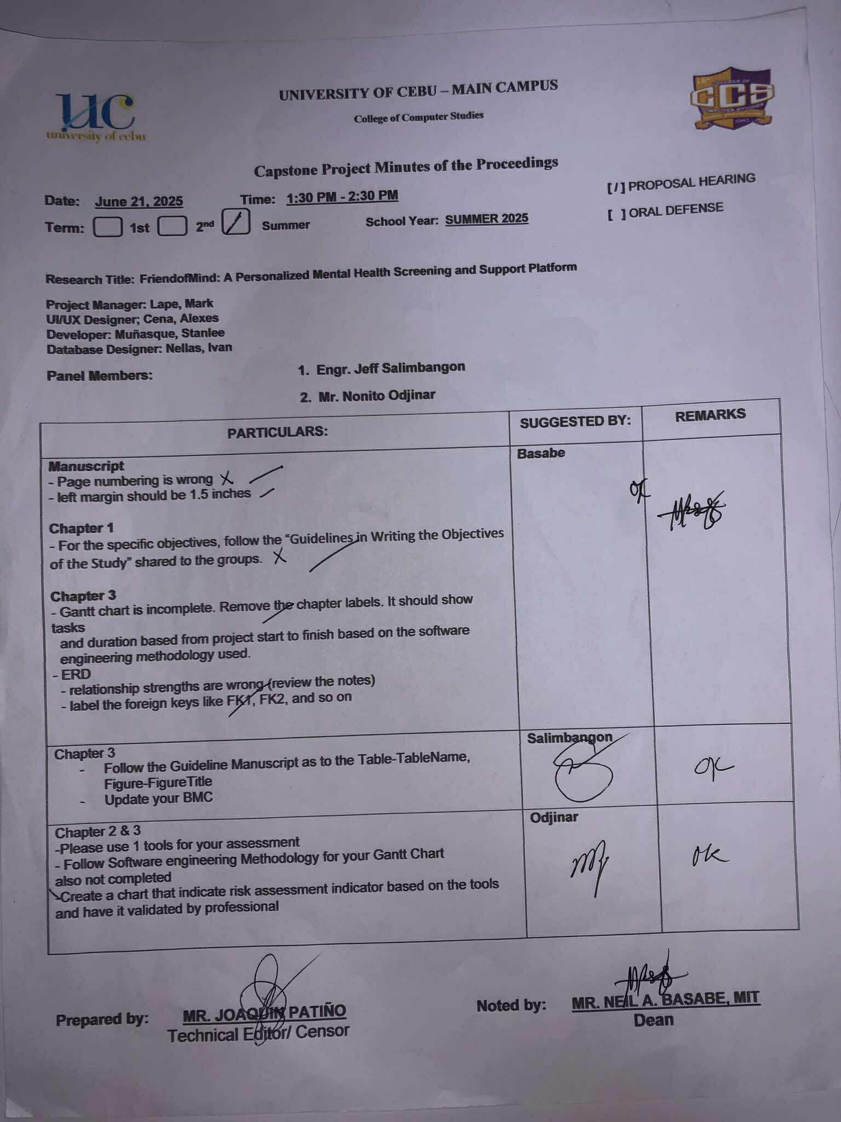

### Appendix K: Honorarium for Panel (Proposal Hearing)

### Appendix L: Research Topic Endorsement

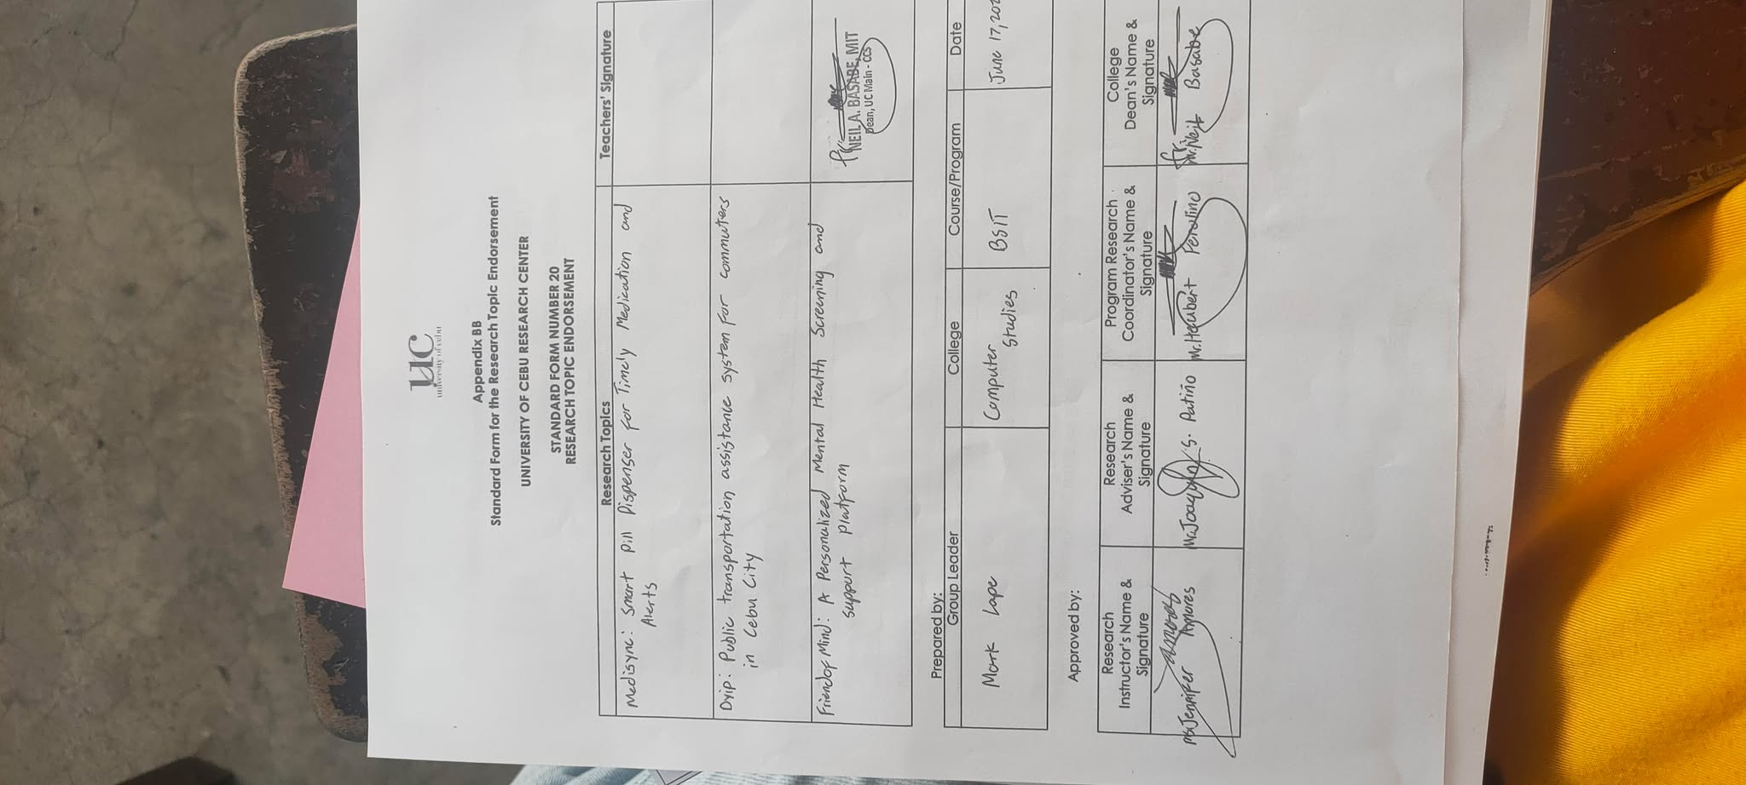

### Appendix M: Proposal Hearing Endorsement Form

### Appendix N: Research Hearing Notice

